GRADE BOOSTER: A STREETCAR NAMED DESIRE  Explore how Williams presents the tension between illusion and reality in ‘A Streetcar Named Desire’ | Contents:  Step 1: Brainstorm – page 1  Step 2: Approach the question via symbolism – page 1  Step 3: Approach the question via Stage directions – page 2  Step 4: Approach the question via Character: Blanche – page 3  Step 5: Approach the question via Character: Stanley – page 4  Step 5: Evaluate and Summarise – page 5

Grade Booster: A Streetcar Named Desire
Explore how Williams presents the tension between illusion and reality in ‘A Streetcar Named Desire’

What does the epigraph suggest about this question?

And so it was I entered the broken world
To trace the visionary company of love, its voice
An instant in the wind (I know not whither hurled)
But not for long to hold each desperate choice

("The Broken Tower" by Hart Crane)

Step 1: Brainstorm:

- Which characters have illusions about themselves, others or the circumstances they live in?
- What ‘reality’ or ‘realities’ are relevant here?
- What different forms do ‘illusions’ take in ‘Streetcar’?
- Which contextual ideas might shape the realities and illusions that Williams presents?
- How does Williams channel the audience’s sympathies – for characters who experience illusions or disillusionment, or for those firmly on the side of reality?
- Which symbols and motifs are relevant to this question?
- How can you include your knowledge of dramatic form (tragedy, tragic hero, expressionism, realism, etc) in your discussion?

Step 2: Approach the question via symbolism:

Which symbolic motifs are relevant to this theme?

- “I don't want realism. I want magic! [Mitch laughs] Yes, yes, magic! I try to give that to people. I misrepresent things to them. I don’t tell the truth, I tell what ought to be truth. And if that is sinful, then let me be damned for it!”
- “Say it’s only a paper moon, Sailing over a cardboard sea—But it wouldn’t be make believe If you believed in me!”
- Stella: What are you laughing at honey? Blanche: Myself, myself, for being such a liar! I’m writing a letter to Shep.
- "'Hey, there! Stella, Baby!...Catch!...Meat!”
- “I can’t stand a naked light bulb, any more than I can stand a rude remark or a vulgar action.”

Step 3: Approach the question via Stage directions:

Stage directions might be expected to enhance the realist aspects of this play – as pragmatic directions as to the setting, performance and stage design. However, Williams’ stage directions are often strongly figurative – they suggest some of the most expressionist elements of the play:

Scene 10:
- As Stanley walks into the bedroom, ‘Lurid reflections appear on the walls around BLANCHE. They are of a grotesque and menacing form.’ (p. 94)
- As she desperately tries to telephone for help while Stanley is in the bathroom, ‘The night is filled with inhuman voices like cries in a jungle.’ (p. 95)
- ‘The shadows and lurid reflections move sinuously as flames along the wall spaces.’ (p. 95)

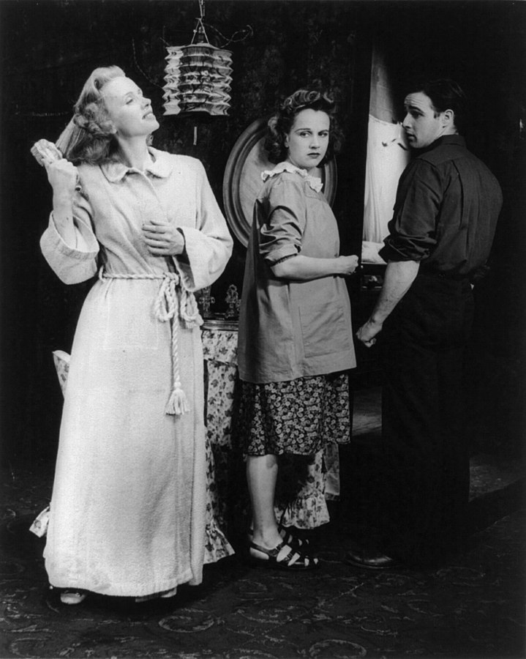
Scene 11: the Varsouviana Polka is “filtered into he obstructs Blanche’s way out of the room. ‘The barely audible ‘blue piano’ begins to drum up weird distortions”
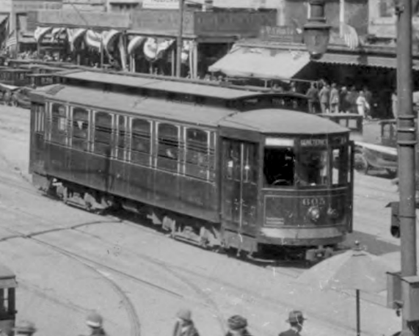
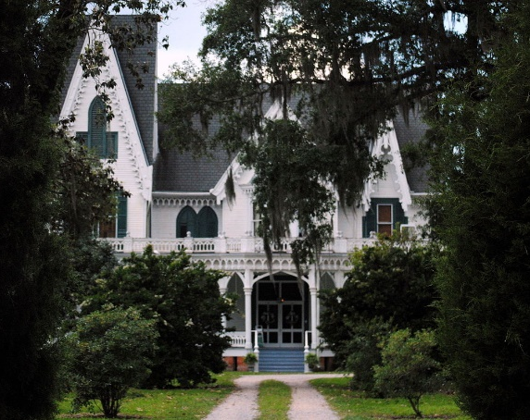

Images: left, A Streetcar performance, Jessica Tandy with Kim Hunter and Marlon Brando (public domain); right top, Ardoyne Plantation, 2015, from user Z28scrambler with license: https://commons.wikimedia.org/wiki/File:Ardoyne_Plantation.JPG; right bottom, Canal Street New Orleans streetcar (public domain).

Step 4: Approach the question via Character: Blanche

- Blanche, telling Stella about Shep Huntley’s oil-wells: ‘Texas is literally spouting gold in his pockets.’ (p. 43) - Blanche, following her comment about Shep Huntley’s oil-wells: ‘Y’know how indifferent I am to money.’ (p. 43)
- Blanche, explaining her name to Mitch: ‘It’s a French name. It means woods and Blanche means white, so the two together mean white woods. Like an orchard in spring! You can remember it by that.’ (pp. 33-34)
- Blanche, who has been drinking since Mitch left, ‘has decked herself out in a somewhat soiled and crumpled white satin evening gown and a pair of scuffed silver slippers with brilliants set in their heels.’ She also places a ‘rhinestone tiara’ on her head in front of the mirror. But when she picks up her hand mirror for a closer inspection, she catches her breath and slams it down so hard that the glass cracks. (p. 90)
- Blanche, talking about Shep Huntley, who she claims is going to take her on a cruise of the Caribbean: ‘Having great wealth sometimes makes people feel lonely! […] A cultivated woman, a woman of intelligence and breeding, can enrich a man’s life – immeasurably! […] Physical beauty is passing. A transitory possession. But beauty of the mind and richness of the spirit and tenderness of the heart […] aren’t taken away, but grow!’
- ‘How strange that I should be called a destitute woman! When I have all of these treasures locked in my heart. [A choked sob comes from her] I think of myself as a very, very rich woman! But I have been foolish – casting my pearls before swine!’ (p. 93)
- BLANCHE. […]And funerals are pretty compared to death. Funerals are quiet, but deaths not always. Sometimes their breathing is hoarse, sometimes it rattles, sometimes they cry out to you, “Don’t let me go!” Even the old sometimes say it- “Don’t let me go”. As if you could stop them! Funerals are quiet, with pretty flowers. And oh, what lovely boxes they pack you away in! Unless you were there at the bed when they cried out “Hold me” you’d never suspect there was struggle for breath and bleeding. You didn’t dream, but I saw! Saw!

Step 5: Approach the question via Character: Stanley

Explaining her need for ‘hydro-therapy’, Blanche claims that a ‘healthy Polack’ like Stanley wouldn’t understand. He replies: ‘I am not a Polack. People from Poland are Poles, not Polacks. But what I am is a one hundred per cent American, born and raised in the greatest country on earth and proud as hell of it, so don’t ever call me a Polack.’ (p. 79)

Is the American Dream an illusion or a reality?

- The men at the poker table: ‘They are men at the peak of their physical manhood, as coarse and direct as the primary colours.’ (p. 27)
- Blanche to Stanley: ‘You’re simple, straightforward and honest, a little bit on the primitive side I should think.’ (p. 21)
- After Stanley has insisted he has a right to his wife’s property under the Napoleonic code, Blanche retorts with: ‘My, but you have an impressive judicial air!’ and then sprays him with her perfume. He then ‘slams [the perfume bottle] down on the dresser’. Blanche ‘throws back her head and laughs’. (p. 22)
- Stella instructs Stanley to ‘be nice’ to Blanche, explaining that ‘she wasn’t expecting to find us in such a small place. You see I’d tried to gloss things over a little in my letters.’ (p. 17)
- Stanley, explaining to Stella what he has found out about Blanche’s past in Laurel: ‘Sister Blanche is no lily! Ha-ha! Some lily she is!’ (p. 70)
- ‘She’s as famous in Laurel as if she was the President of the United States, only she is not respected by any party!’ (p. 70)
- ‘The trouble with Dame Blanche was that she couldn’t put on her act any more in Laurel!’ (p. 71)
- ‘for the last year or two she has been washed up like poison […] That’s why she’s here this summer, visiting royalty, putting on all this act’ (p. 71)
- Stanley to Stella: ‘When we first met, me and you, you thought I was common. How right you was baby, I was common as dirt. You showed me the snapshot of the place with the columns. I pulled you down off them columns and how you loved it, having them coloured lights going!’ (p. 81)
- Stanley: ‘And look at yourself! Take a look at yourself in that worn-out Mardi Gras outfit, rented for fifty cents from some rag-picker! And with the crazy crown on! What queen do you think you are!’ (p. 94)

Step 6: Evaluate and Summarise:

- What prevails in the end?
- Illusion or Reality?

Evaluate the final scene!

Cheat Sheet:
- ‘I’ll be buried at sea sewn up in a clean white sack and dropped overboard – at noon – in the blaze of summer – and into an ocean as blue as my first lover’s eyes!’ (p. 102)
When the doctor arrives:
- Once she has encountered the doctor on the porch, Blanche turns back into the flat and rushes past Stanley, who tries to obstruct her with his chair, into the bedroom. At this point ‘Lurid reflections appear on the walls in odd, sinuous shapes. The ‘Varsouviana’ is filtered into weird distortion, accompanied by the cries and noises of the jungle. Blanche seizes the back of the chair as if to defend herself.’ (p. 104)
- Last sentence of the play: “This game is seven-card stud”

