GRADE BOOSTER: A STREETCAR NAMED DESIRE  Exploring Form and Context: Why might Williams have chosen this particular dramatic form to address specific contextual issues? | Contents:  Introduction and Starter – page 1  Step 1: Context – Key Ideas – page 2  Step 2: Dramatic Form – page 3  Step 3: Evaluating Form: - page 4  Step 4: Williams’ Plastic Theatre – page 8  Step 5: Summarise and Evaluate- page 8
Grade Booster: A Streetcar Named Desire
Exploring Form and Context: Why might Williams have chosen this particular dramatic form to address specific contextual issues?

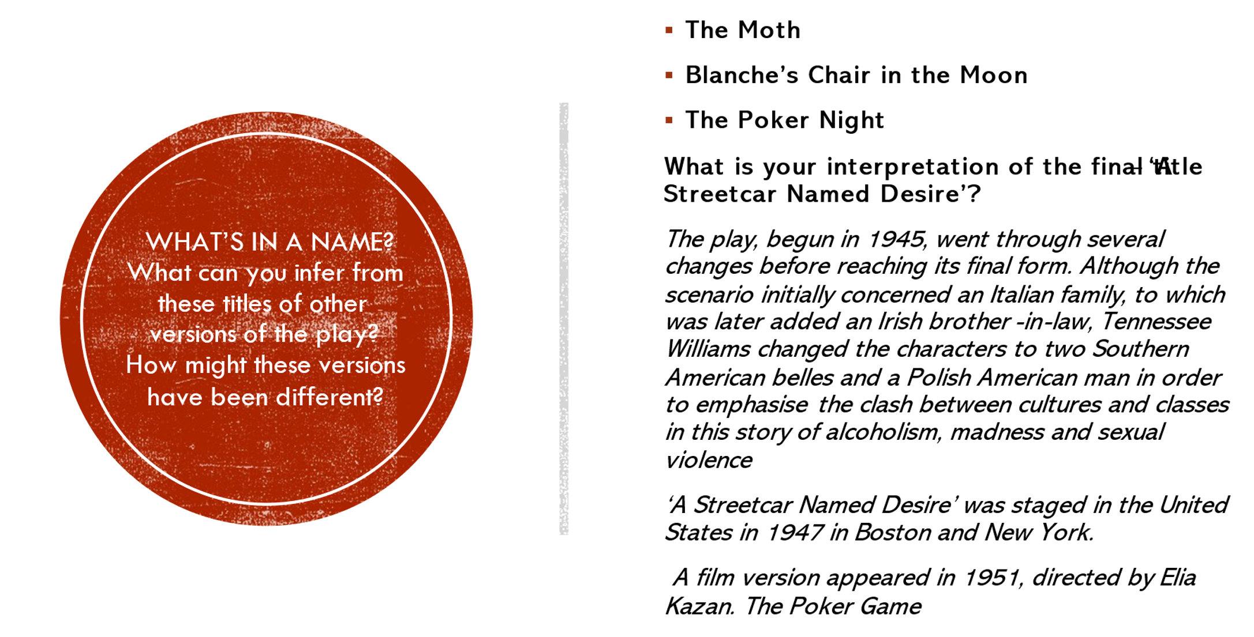
According to Williams, Streetcar is about “the ravishment of the tender, the sensitive, the delicate, by the savage and brutal forces of modern society.” However, the play developed over time. Before exploring form and context in more detail complete these two starter activities:
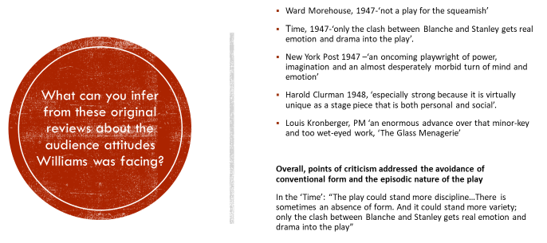

In more depth:
Explore Brooks Atkinson’s original 1947 review. What differences in perception might have shaped his opinion on the play compared to a theatre critic’s views in 2022? https://archive.nytimes.com/www.nytimes.com/interactive/2012/04/23/theater/20120423-streetcar.html?_r=0

Step 1: Context – Key Ideas

5-minute challenge: Pick 2-3 of these topics and write down all the relevant contextual facts you can remember! How does the play respond to these issues?

- The American Civil War 1861 – 5….
- Resulting attitudes towards the Deep South / The Deep South & Tensions between Old South and new social order / The myth of the American South (see the success of Gone with the Wind, 1939)
- The Southern Gothic
- Immigration to America in the early 21st century
- Attitudes to men/masculinity/women/ sexuality
- Homosexuality and the law and Williams’ attitude to homosexuality 1930s – 1960s
- the City/Urban Life/New Orleans
- Contemporary attitudes to men and women and sexuality
- Violence / brutality / confrontation
- Williams’ own biography

Not sure? Use the Cheat Sheet to help you get started, or to check your ideas:

Step 2: Dramatic Form
‘Streetcar’ is a play set in times of change and uncertainty. It is therefore no surprise that it references a broad range of dramatic conventions.

Your task:
- Learn about relevant artistic, literary and dramatic forms, using the infoboxes on the following pages.
- Which aspects of ‘Streetcar’ are inspired by each of these forms?
- Why might Williams have been interested in this form?

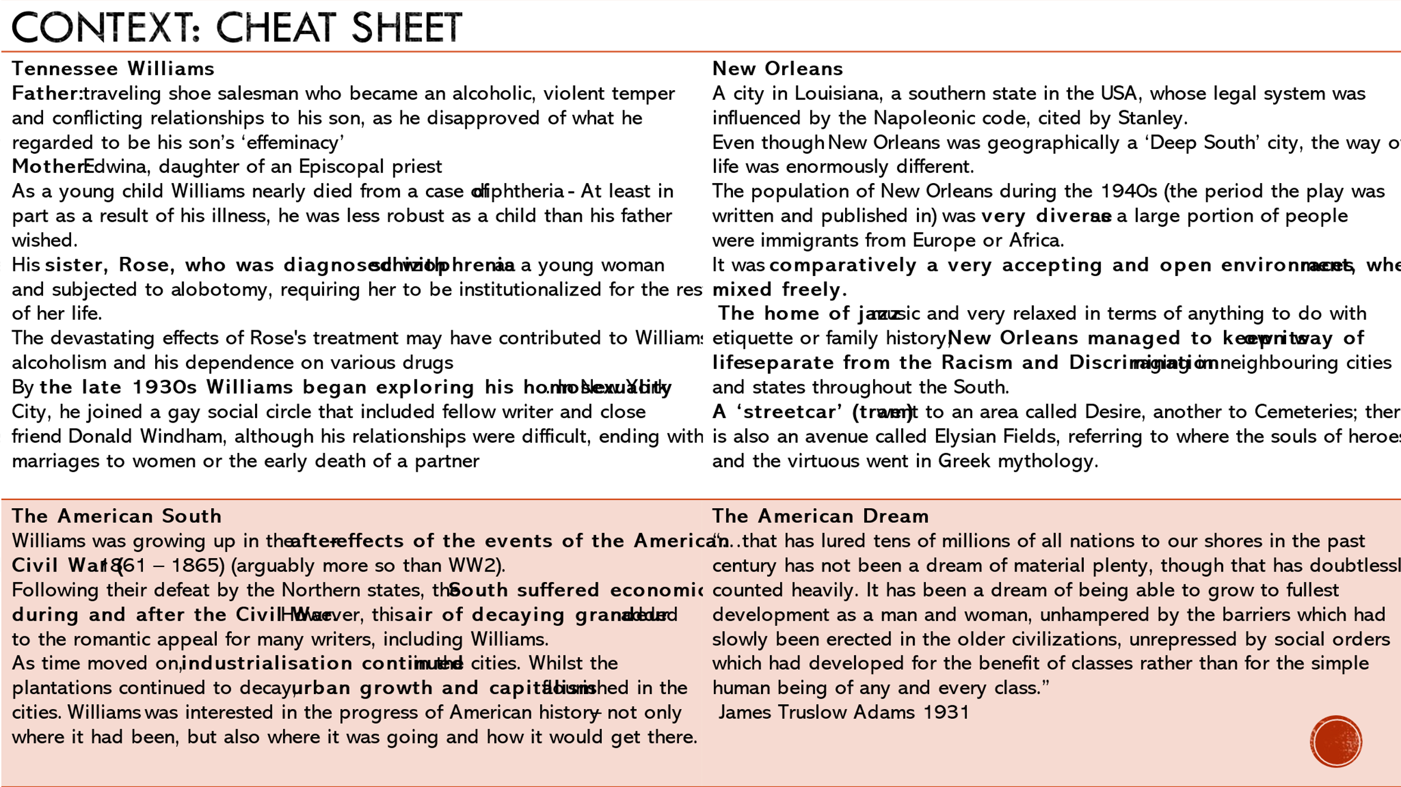
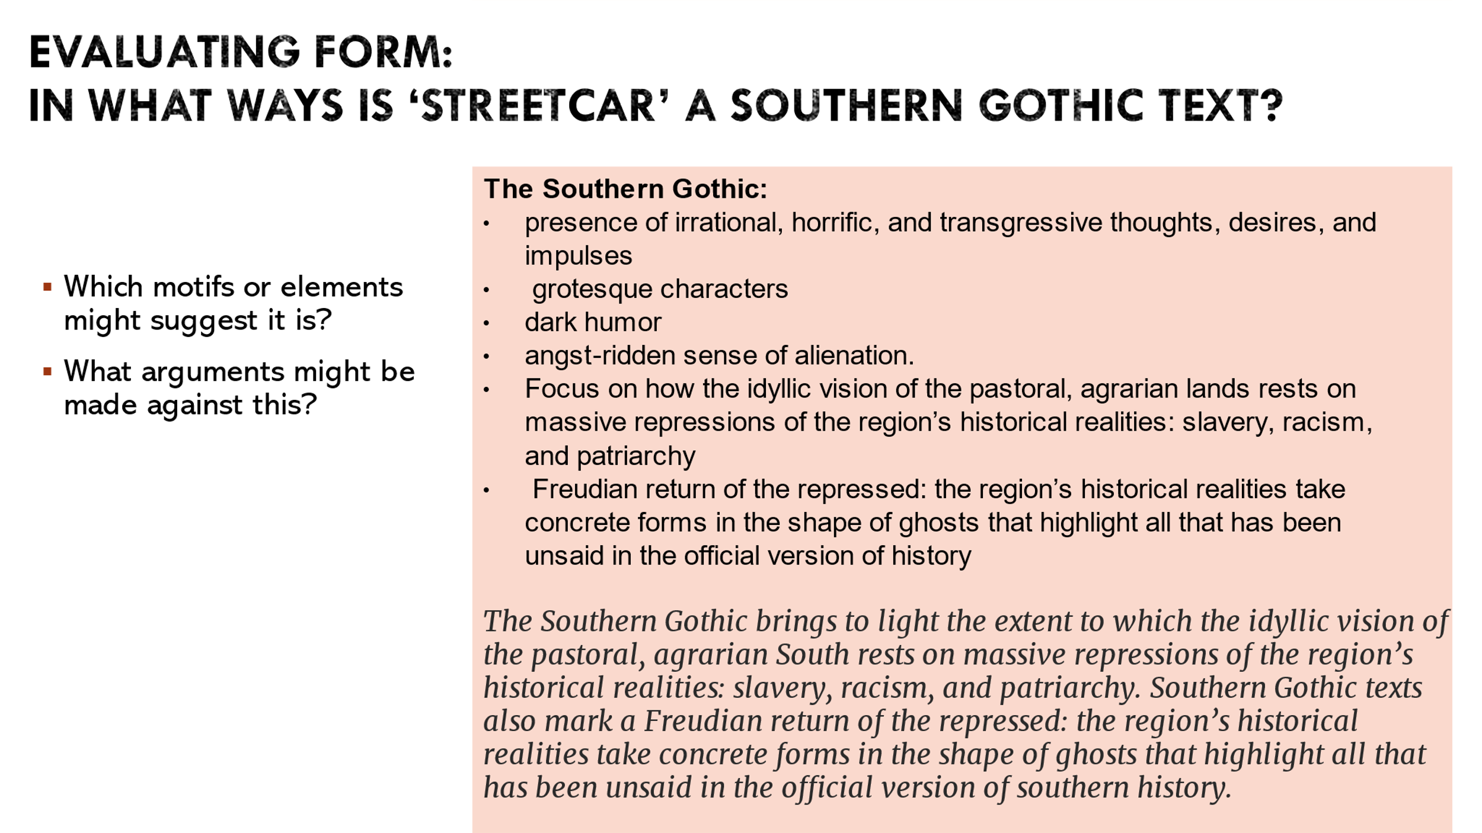

Step 3: Evaluating Form:
Staging Change – Unpredictability and Ambiguity

Given the contexts and themes Williams was referring to, why might he have chosen such an ambivalent, unpredictable form?
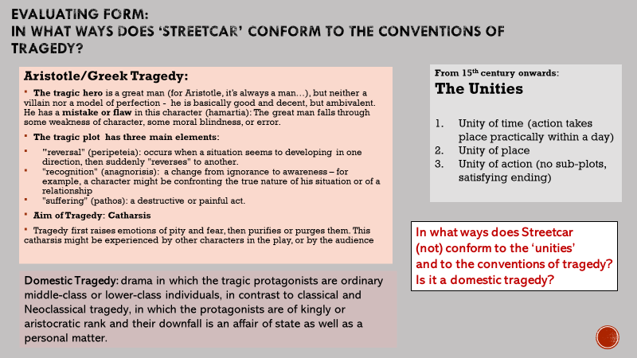

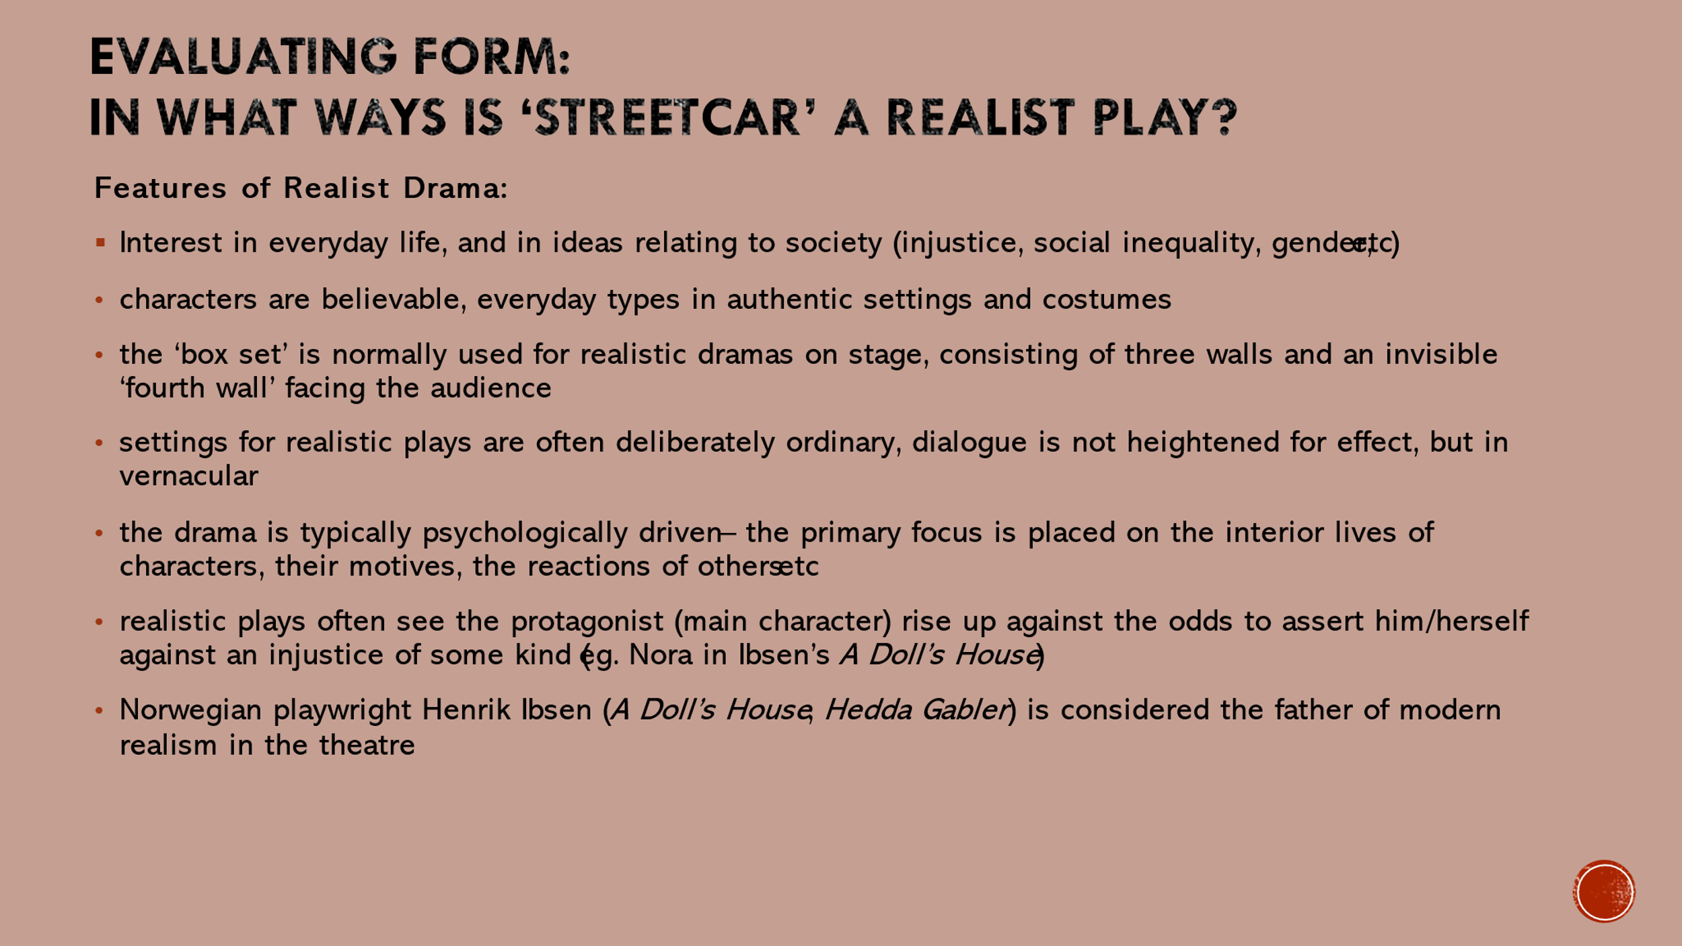
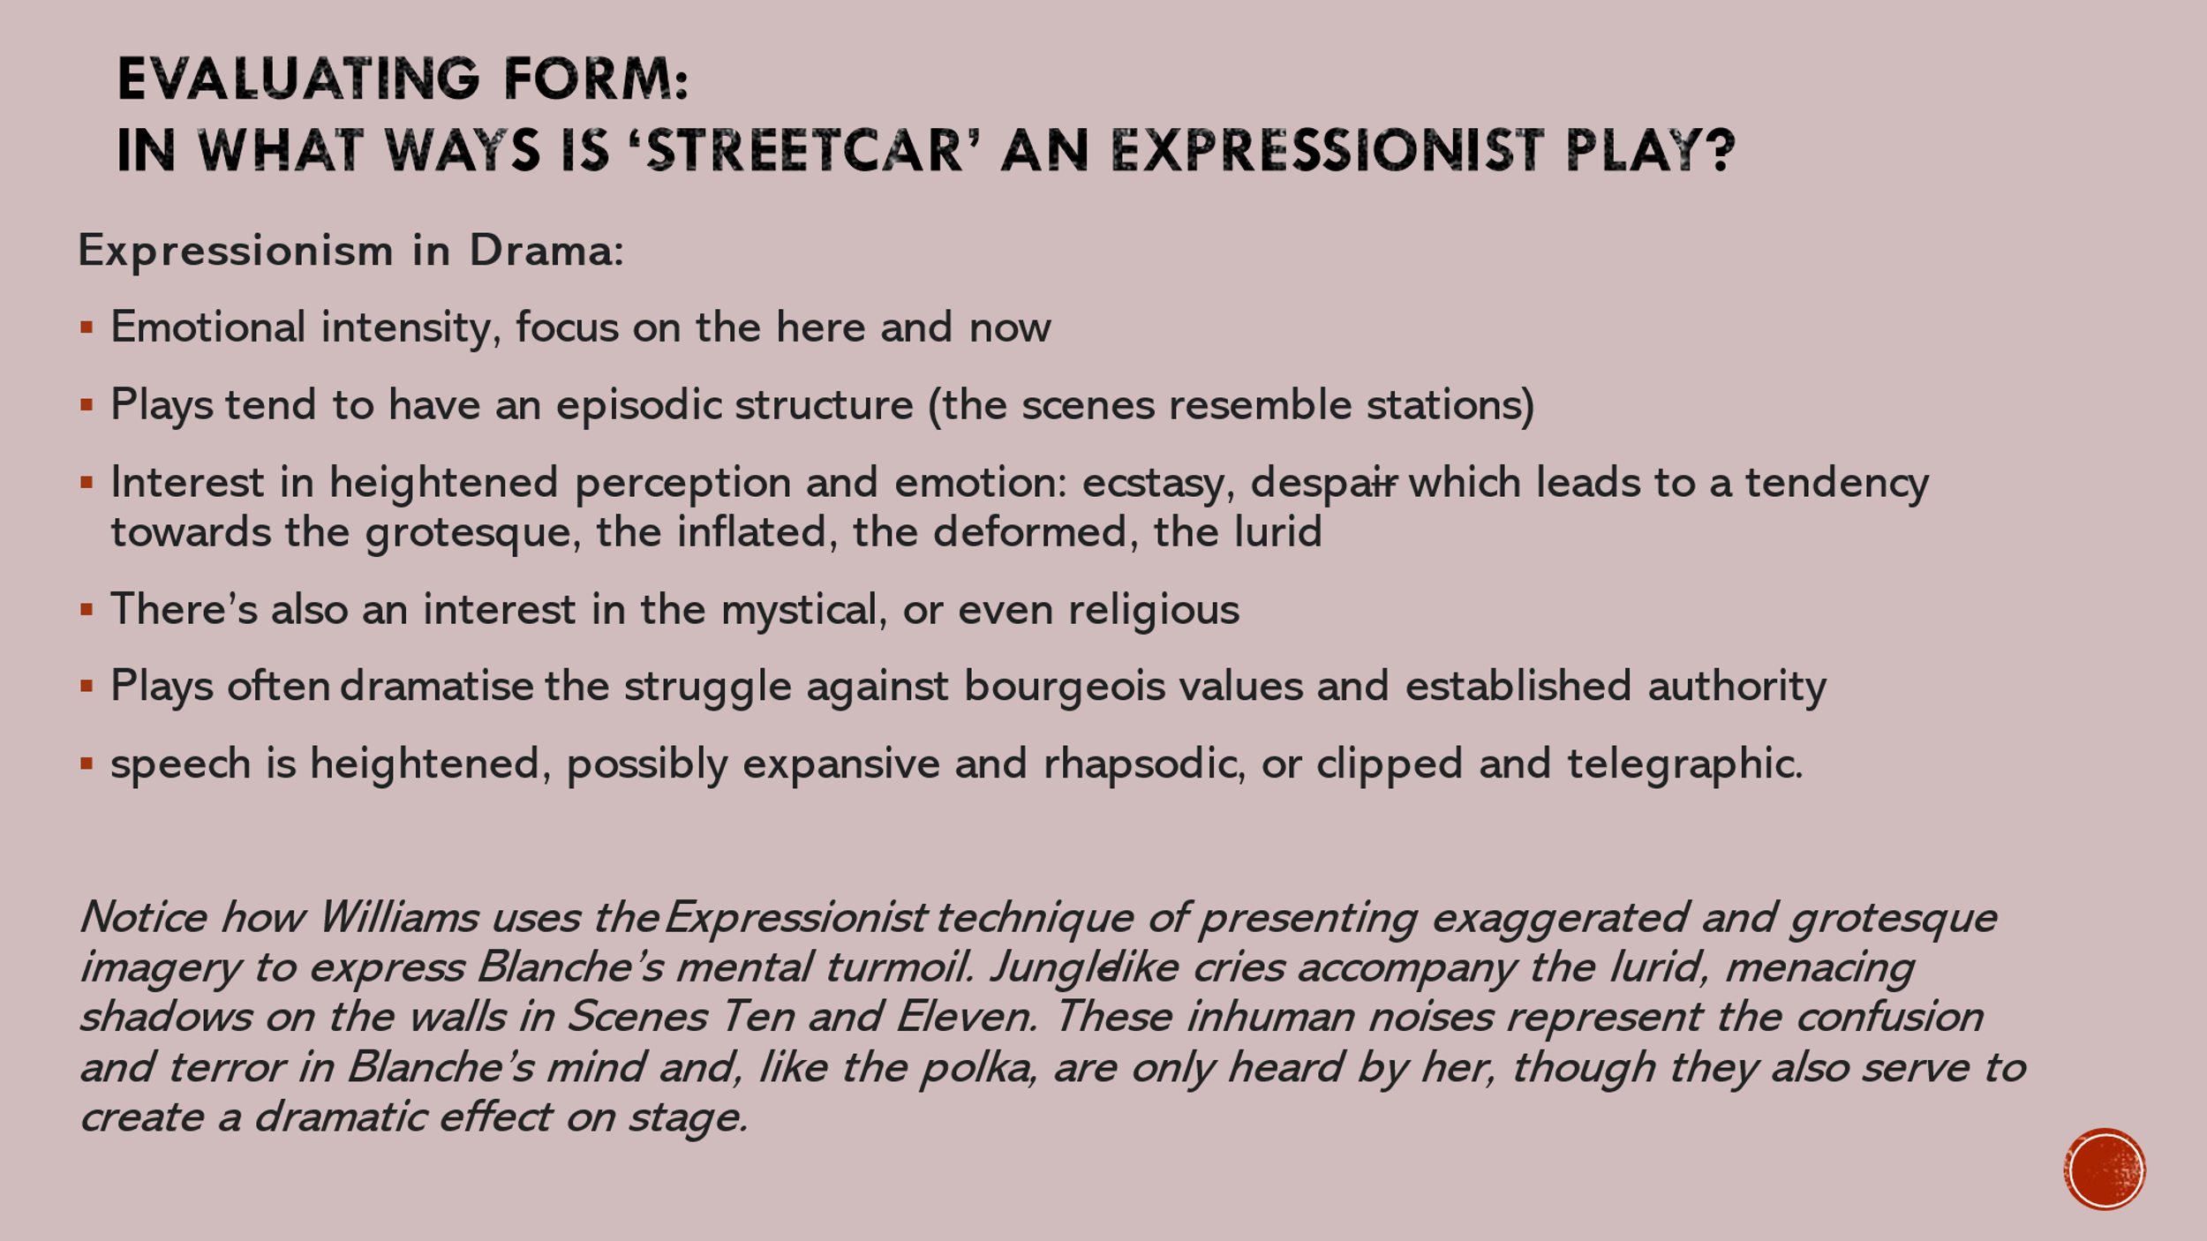
In more depth:
- Here is what realist artwork looks like: https://www.tate.org.uk/art/art-terms/r/realism
- You can explore expressionist artwork here: https://www.tate.org.uk/art/art-terms/e/expressionism
- The distorted forms of expressionism can be seen in this trailer of ‘The Cabinet Of Dr. Caligari (1920): https://youtu.be/IAtpxqajFak

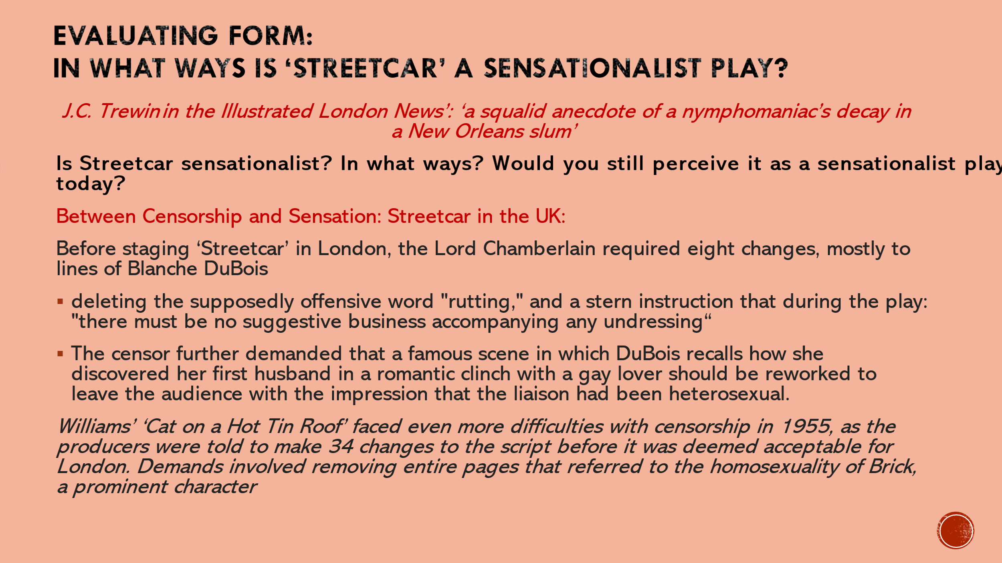

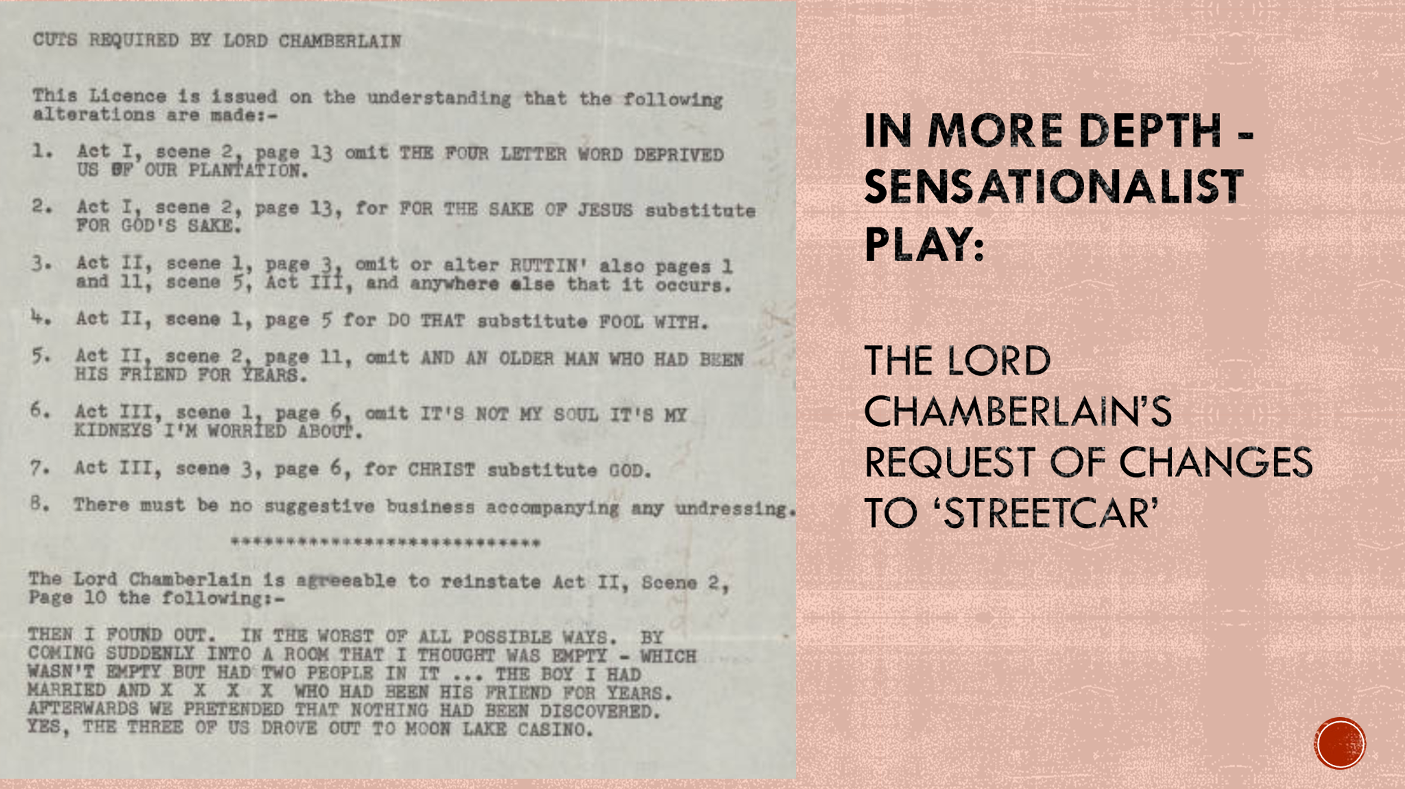

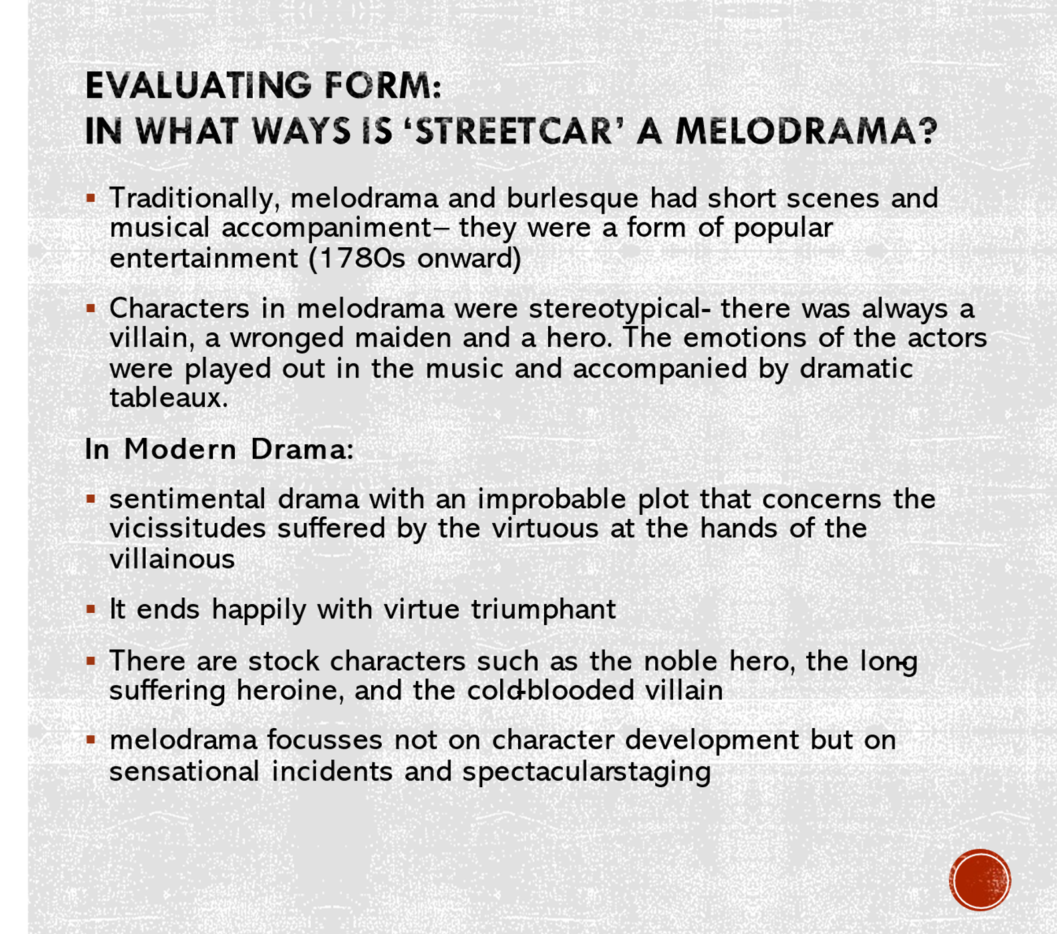

Step 4: Williams’ Innovation:
“The Sculptural Drama” of Plastic Theatre

Take notes of the features of this ‘plastic theatre’ - How can these ideas help explain the form of ‘Streetcar’?

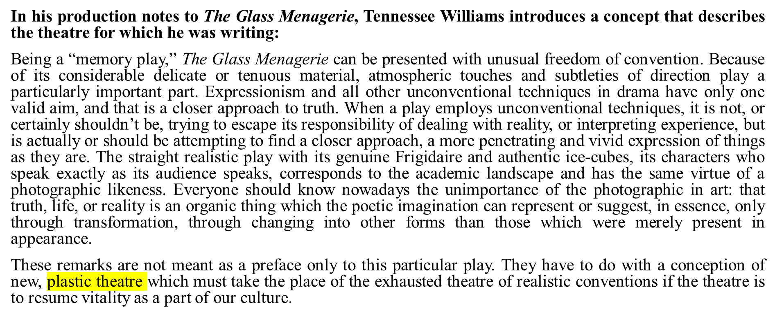

Step 5: Summarise and Evaluate:

How would you characterise the dramatic form of Streetcar?
Given the contextual ideas Williams was addressing, why might he have chosen this particular dramatic form?

