To what extent does James Van Der Zee’s work reflect the values of the Harlem Renaissance?
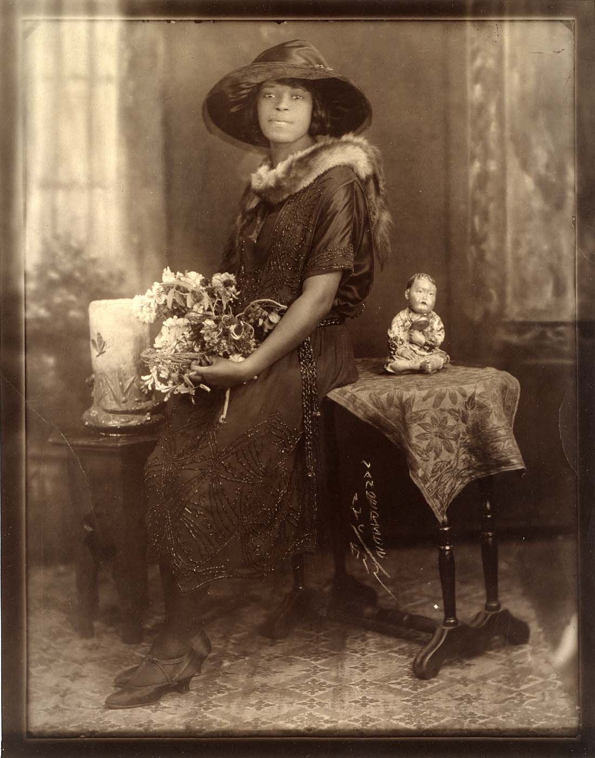
Below is a photograph taken by James Van Der Zee. What do you think are some of the most important features of the image?
James Van Der Zee, “Evening Attire,” 1922
[Source: Wikimedia Commons. This image is in the public domain due to a cooperation agreement between Wikimedia Commons and the Smithsonian Art Museum. The UK applies the rule of the shorter term for US work, hence this is out of copyright. Link here: https://commons.wikimedia.org/wiki/File:Evening_Attire.jpg ]
Task: Write an analysis of the above image, considering to what extent it reflects the values of the Harlem Renaissance. Topics to consider include:
- The composition of the image – what is in the image? What is in the background / foreground? What draws your attention?
- The values of the Harlem Renaissance – does the image represent the idea of the ‘New Negro’? How does it represent gender / class / race?

