Can you analyse a photograph?
Photography – and other kinds of visual culture – can be important artifacts that tell a story about a moment in history. Whilst there is no ‘correct’ way to analyse a photograph, taking a closer look at the images we use to tell our histories can deepen our understanding.
For your activity, you should write an analysis of an image of your choosing. It can be a favourite one from a course you have studied so far, or one of the few images on the second page of this worksheet.
Here are some questions to prompt your analysis:
- CONTENT: How is the photo composed? What is in the foreground / background?
- CONTEXT: How does knowing a little bit of the context of the photograph shape your understanding of it? Does the identity of the photographer change this as well?
- COMMENT: Apply Roland Barthes’s idea of the studium and the punctum to your chosen image. Do you have a unique, emotional reaction to this photograph at all? Why / why not?
Use these prompts to answer the question: What impression does your chosen image give of the history it is recording?

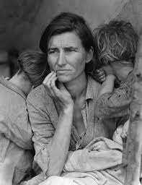

Dorothea Lange, The Migrant Mother, 1936
Photographer Dorothea Lange took this photograph during the Great Depression. The Great Depression was a period of extreme economic downturn in the United States and around the world, that arguably started with the Wall Street Crash in 1929.
When she took this image, Dorothea Lange was employed by the Resettlement Administration. This was a New Deal agency designed to support the relocation of workers. Lange came across this woman and her children at a Pea Pickers Camp of 2,500 people. The woman’s name is Florence Owens Thompson.
Despite being a documentary photographer, after first taking some candid photographs, Lange asked the mother to pose for this image – in particular, she asked her children to lean on her with their faces away from the camera.

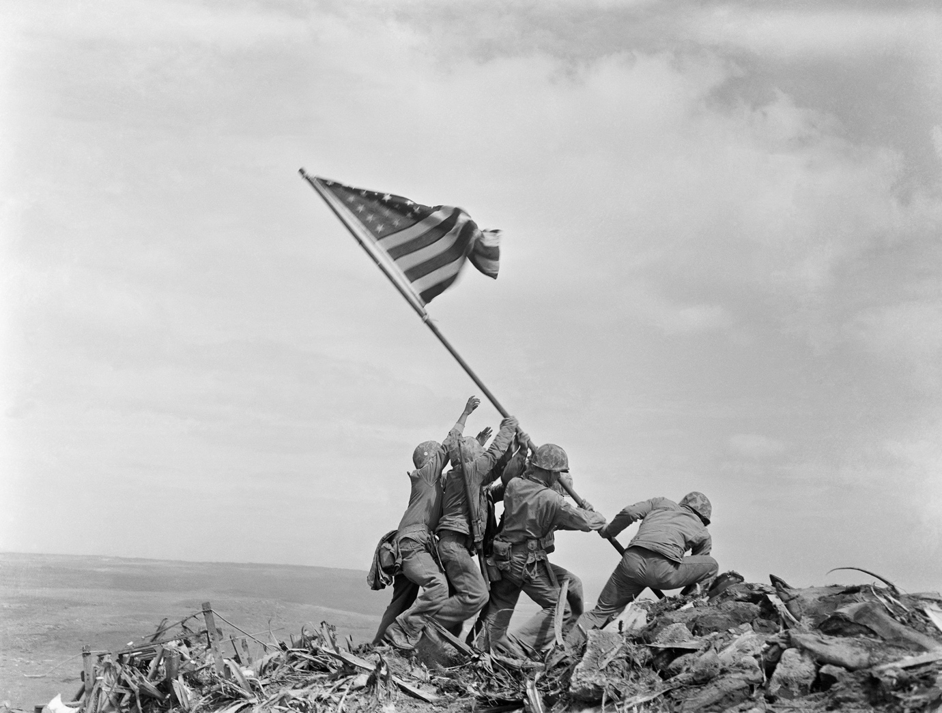
Joe Rosenthal, Raising the Flag at Iwo Jima, Japan, 1945.
This image shows six US Marines raising an American flag on a battlefield. This took place on top of Mount Suribachi in Japan. It was part of the Pacific War action in World War Two, where allied forces adopted an ‘island hopping’ strategy to defeat Japan. Three of the men in this image were killed over the next few days.
This was the second flag raising that took place. A smaller flag was raised earlier in the day, but was replaced by the larger flag which is seen in this image. There has also been a great degree of uncertainty around the identities of the men in the photograph, with many having been misidentified in the past.
The image has become iconic of American involvement in World War Two. Among appearing on stamps and coins, it became the basis for a memorial for Marines by Felix de Weldon which was revealed in 1954.

