What narratives do photographs of the Civil Rights Movement tell?
Photography provided important coverage of African American activism in the Civil Rights Movement. Journalists, activists, and everyday people took images that would shape how the Civil Rights Movement was seen around the world. Looking at the below image, what is your immediate impression of it?

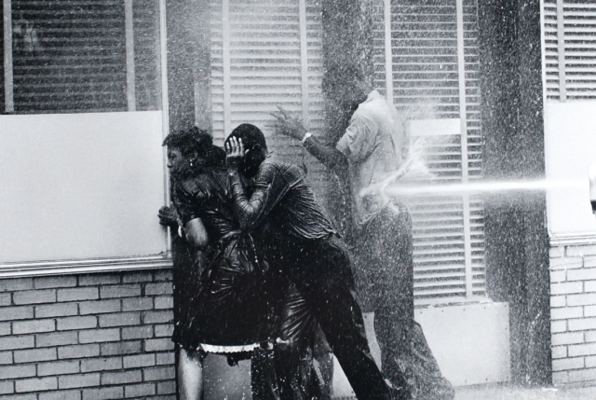

Protestors in Birmingham, Alabama being hit by a high-pressure fire hose (1963). Photograph by Charles Moore.

This image was taken as part of the Birmingham Campaign. This was a period of concentrated non-violent protest in Birmingham, Alabama by the Southern Christian Leadership Conference (SCLC). Leaders such as Martin Luther King, Jr. allowed children to participate in the actions. The Commissioner of Public Safety – local white supremacist Eugene “Bull” Connor – permitted the police’s use of fire hoses and dogs to attack bystanders and protestors.

Charles Moore was a white photojournalist. Moore had been a photographer in the US Marines for three years. He then became chief photographer for The Montgomery Advisor, before starting as a freelance photographer in 1962.

Task: Use the below grid to write a source analysis of the above photograph. Consider the over-arching question: How does this image help us understand the Civil Rights Movement?

Content of the photograph | What is the focus of the photograph (focal point)? What is in the background and what is in the foreground? What message do you think the photograph is trying to convey?
Context of the photograph | How does this image reflect your understanding of the wider Civil Rights Movement? What might it tell us about the following ideas: Gender / Nonviolence / Leadership.
The photographer | Do you think the photographer’s identity would impact the photograph? What might their agenda be? Do you think that they would have access to spaces that other photographers might not?
Audience reaction | How do you think that the following audiences might react to this photograph: (1) African American activists, (2) American politicians, (3) sympathetic white liberals, (4) white supremacists, (5) international audiences from other countries.

