AMERICAN LITERATURE BETWEEN THE WARS  Text Pairing: Zora Neale Hurston’s ‘Their Eyes Were Watching God’ and F. Scott Fitzgerald’s ‘The Great Gatsby’ | 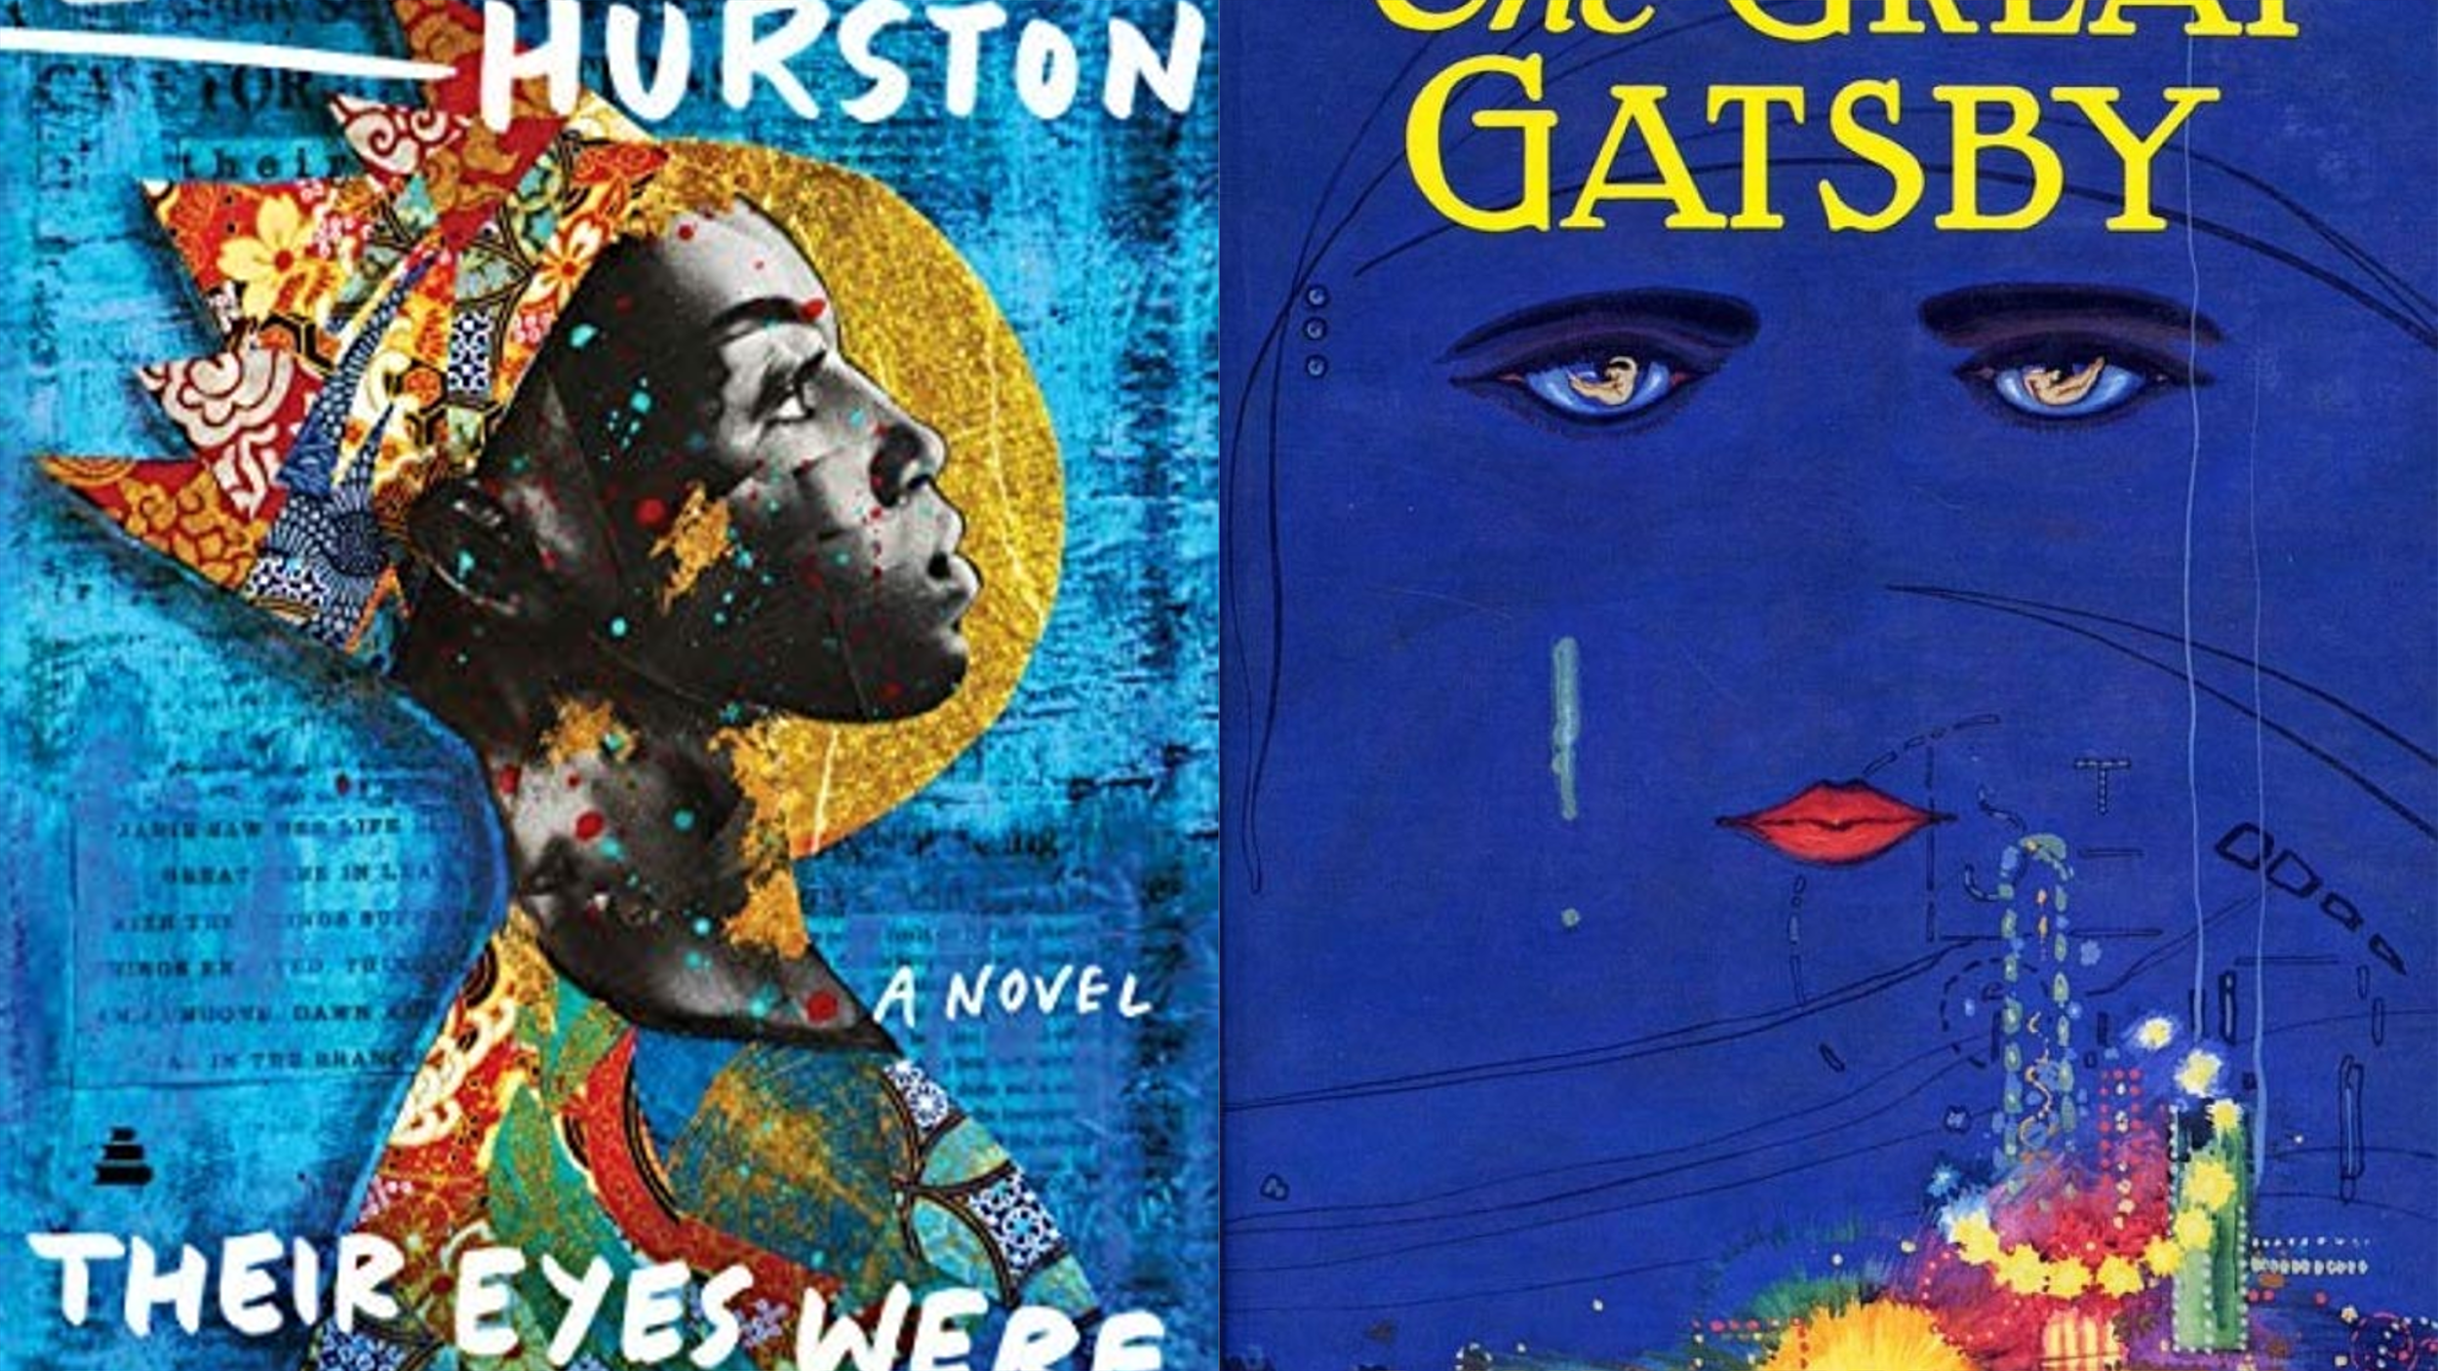  HOW CAN THIS RESOURCE BE USED?  The Great Gatsby is perhaps the most well-known and widely taught novel of the interwar years in the US, and has become synonymous with the Jazz Age. However, this tragic romance tells only part of the story of US culture and literature in the 1920s and 30s. This text pairing introduces you to another classic of US-American Literature: Zora Neale Hurston’s Their Eyes Were Watching God. This resource is designed to support teachers, but can also be used as an independent study resource for students. Use it to inspire coursework pairings and to expand your and your students’ literary horizons!
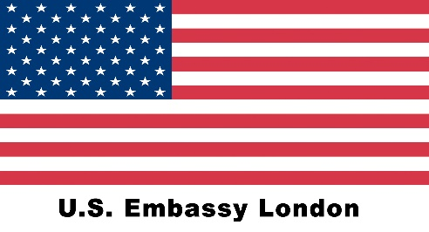

Contents
Why should I read these two texts together? 2
Before you start: 2
Explore the authors and their legacies: 2
Zora Neale Hurston – recommended resources: 2
F. Scott Fitzgerald – recommended resources: 3
One country, different worlds? 3
Zora Neale Hurston’s world: 3
F. Scott Fitzgerald’s world 4
How do the novels compare and contrast? Explore shared themes! 5
The American Dream 5
The Role of Women 5
Diversity 6
Music 6
Romantic Relationships 6
Death 7

Why should I read these two texts together?

The 1920s and 30s were an incredibly complex time in the US. While The Great Gatsby reflects some of the wild glamour of the Roaring Twenties, it’s important to be aware that this is just one story among many that need to be told about this era. Zora Neale Hurston offers the necessary counter-perspective to Fitzgerald’s urban, white vision. Her novel is also a love story, but it is set in places and among characters who seem worlds apart from Fitzgerald’s privileged set of partygoers. And yet their story is just as – or perhaps even more – representative of this time in US literature and culture.

Before you start:
Chimamanda Adichie’s TED talk on ‘The Danger of a Single Story’ offers great impulses for thought and discussion about the consequences of privileging one particular ‘story’ or voice over others. https://www.ted.com/talks/chimamanda_ngozi_adichie_the_danger_of_a_single_story?language=en

Explore the authors and their legacies:

Zora Neale Hurston – recommended resources:
- The New York Public Library offers a helpful overview of her work: https://www.nypl.org/blog/2019/09/16/where-start-zora-neale-hurston
- You can download the podcast ‘A Woman Half in Shadow’ on the BBC Sounds website, which explores the author’s life and legacy, https://www.bbc.co.uk/programmes/p04zzrsv
- The National Women’s History Museum offers this introduction to Zora Neale Hurston https://www.womenshistory.org/education-resources/biographies/zora-hurston. When you click on ‘Additional Resources’, you will get access to the Zora Neale Hurston Digital Archive, an invaluable resource inducing media resources, critical articles, summaries, and background information for a anyone considering writing about Zora Neale Hurston in their coursework – lesson plans and resources for teachers are also provided https://chdr.cah.ucf.edu/hurstonarchive/
- For the more historically inclined, recommended resources include the ‘Florida Memory’ section on Zora Neale Hurston (https://www.floridamemory.com/learn/classroom/learning-units/zora-neale-hurston/ ) and the Library of Congress’ guide to the author (https://guides.loc.gov/zora-neale-hurston ) – browse these websites for lesson plans and a broad range of historical documents relating to Zora Neale Hurston and her work

F. Scott Fitzgerald – recommended resources:
- Browse the Encyclopaedia Britannica for information on the author https://www.britannica.com/biography/F-Scott-Fitzgerald. Another good overview is provided by the Writers Inspire website (University of Oxford), http://writersinspire.org/content/curious-life-f-scott-fitzgerald
- Listen to the Podcast ‘Fitzgerald Beyond Gatsby’ provided by Oxford University, https://podcasts.ox.ac.uk/fitzgerald-beyond-gatsby
- The ‘Conversation’ offers a good overview of key ideas in the novel, https://theconversation.com/guide-to-the-classics-the-great-gatsby-112508
- Read this thought-provoking article on ‘The world's most misunderstood novel’ for some first ideas for how to read ‘The Great Gatsby’ differently https://www.bbc.com/culture/article/20210209-the-worlds-most-misunderstood-novel
- Lithub offers a podcast titled ‘Is The Great Gatsby Actually Profound?’ for critical discussion of this novel, https://lithub.com/is-the-great-gatsby-actually-profound/

One country, different worlds?
When you read both novels, you might find that it seems almost as if they were set in different worlds. And yet, both tell of different realities in the US at the time. Use the following resources to help you compare and contrast the historical and cultural contexts each novel is set in:

Zora Neale Hurston’s world:
- To understand Zora Neale Hurston in the context of the cultural moment she helped shape, you’ll need to find out about the Harlem Renaissance – this website is a great starting point https://www.poetryfoundation.org/collections/145704/an-introduction-to-the-harlem-renaissance; develop your understanding further by exploring the role of Southern writers at the time, https://www.pbslearningmedia.org/resource/aa1804fd-a966-45d2-b8b6-874ffb69f402/southern-renaissance-american-passages-authors/
- But what about the rural culture in the novel? PBS offers a range of resources and videos which you can use to learn about and immerse yourself in this place and time. Recommended resources include:
Video exploring the public reaction to the novel - https://www.pbslearningmedia.org/resource/aml15.ela.lit.pubreact/public-reaction-to-their-eyes-were-watching-god/
A media gallery exploring the novel’s main inspiration for the setting – Eatonville, Florida https://www.pbslearningmedia.org/resource/aml15.ela.lit.setting/setting-eatonville-florida/
- This resource set offers a teaching guide to navigate relevant historical sources, https://dp.la/primary-source-sets/their-eyes-were-watching-god-by-zora-neale-hurston#tabs

F. Scott Fitzgerald’s world
- Overview of how ‘The Great Gatsby’ captured the Roaring Twenties: https://www.history.com/news/great-gatsby-roaring-twenties-fitzgerald-dark-side
- The Age of Excess? http://ap.gilderlehrman.org/history-by-era/roaring-twenties/essays/f-scott-fitzgerald-and-age-excess
- The Jazz Age: https://www.pbs.org/wgbh/americanexperience/features/monkeytrial-jazz-age/
- Explore the novel’s context using Library of Congress resources, https://blogs.loc.gov/teachers/2015/03/the-great-gatsby-establishing-the-historical-context-with-primary-sources/ ; you can explore the historical context in even more depth using this guide https://www.loc.gov/classroom-materials/great-gatsby-primary-sources-from-the-roaring-twenties/
- Read Fitzgerald’s own article, ‘Echoes of the Jazz Age’, https://pdcrodas.webs.ull.es/anglo/ScottFitzgeraldEchoesOfTheJazzAge.pdf

How do the novels compare and contrast? Explore shared themes!

The American Dream
Both novels explore the American Dream, but do so with some significant differences.
To get started, you can explore different meanings of the American Dream here https://www.smithsonianmag.com/history/behold-america-american-dream-slogan-book-sarah-churchwell-180970311/

Here’s how you can begin to explore this theme:
- Read Joe Starks’ introduction in chapter 4 of ‘Their Eyes were Watching God,’ and compare this to how Gatsby is introduced in chapter 3 of Fitzgerald’s novel.
- Doing business: how are Joe Starks’ shop opening in chapter 5 and Gatsby’s business dealings in chapter 4 related to the American Dream? You can also include Gatsby’s backstory (chapter 6) when exploring this.
- Status Symbols: Read how Gatsby shows Daisy his house in chapter 5, and compare this to the description of Joe Starks’ house in chapter 5
- The limits of the American Dream – the decline of the dreamers: explore Joe Starks’ demise in chapter 7, and compare it to Gatsby’s disillusionment in chapter 8
- Beyond the ‘American Dream’: who else in the novels has dreams of a different sort? What are these dreams? Are they fulfilled?

The Role of Women
To get ready, use the following resources to learn more about the role of women in US American society:
- Explore this online exhibit for details on women’s fashion and what it expressed (scroll down to the 1920s!) https://www.womenshistory.org/exhibits/fashioning-yourself
- Explore this online exhibit to find out about women’s contribution to political culture https://www.womenshistory.org/exhibits/creating-female-political-culture
- knowing about Black Feminism is especially important for students of Zora Neale Hurston, https://nmaahc.si.edu/explore/stories/revolutionary-practice-black-feminisms
- Zelda Fitzgerald was famous as a flapper – find out more about flappers here https://www.history.com/topics/roaring-twenties/flappers

Here’s how you can begin to explore this theme:
- Explore Nanny as a character in chapter 2 of ‘Their Eyes were Watching God’ – how does her perception of women’s roles clash with Janie’s? To answer this question, it’s worthwhile going back to chapter 1 and exploring the attitudes of the people who watch Janie return – what can you infer about her view of her role as a woman?
- Compare and contrast how Nanny and Janie are introduced to Daisy and Jordan at the beginning of ‘The Great Gatsby’ – how can you explain the differences?
- It’s also interesting to contrast Myrtle, in chapter 2, with Daisy in chapter 5 when she meets Gatsby – how does this compare to when Janie meets Tea Cake, and to her new life in chapters 13 / 14? How does class affect gender roles in both novels?
- Compare the female characters at the end of each novel – have they found their voice? Are they retreating into well-established roles? Compare and contrast!

Diversity
Both novels, in very different ways, reflect the fact that US-American society in the 1920s was very diverse.
- This article explores nascent and continuing tensions, https://theconversation.com/divided-we-stand-looking-back-to-the-1920s-to-understand-the-united-states-today-108028
- On the one hand, the Harlem Renaissance exemplified a revival in African American culture https://nmaahc.si.edu/explore/stories/new-african-american-identity-harlem-renaissance; on the other hand, the Jim Crow Laws and segregation in the American South continued https://www.history.com/topics/early-20th-century-us/jim-crow-laws
Here’s how you can begin to explore this theme:
- Explore Janie’s life in the Everglades (chapters 15-17): how do different groups live together?
- Compare this to Fitzgerald’s descriptions of the trips to New York – chapters 2 and 4. Is the city presented to be diverse? What about Gatsby’s parties, for example in chapter 3 – Jazz is being played, so one might expect non-white artists to be present. How would you evaluate the (lack of) diversity in Fitzgerald’s world?
- Compare Mrs Turner (also in the Everglades, chapters 15 and 16) to Tom Buchanan’s white supremacist views in chapter 1 – in your opinion, to what purpose is each of these characters and attitudes included in the novel?

Music
Both novels are driven by music – atmospherically, and sometimes even plot-wise. You can explore relevant music trends here https://www.thepeoplehistory.com/20smusic.html

- Compare Tea Cake’s guitar playing and singing to the music played at Gatsby’s parties. What is the role of music in each of these scenes? Which different styles are being played?

Romantic Relationships
At their core, both novels are love stories, and follow their protagonists’ journeys when searching for true love. You can explore dating and courtship in the 1920s and 1930s here https://www.huffpost.com/entry/dating-in-the-1920s_b_3239978 or here https://prohibition.themobmuseum.org/the-history/how-prohibition-changed-american-culture/dating-during-prohibition/

These are the main love relationships in the novels:
- Janie and Logan Killick
- Janie and Joe Starks
- Janie and Tea Cake

- Nick and Jordan
- Tom and Daisy
- Tom and Myrtle
- Gatsby and Daisy

How would you characterise each? Which are comparable? Which contrast?
Overall, especially considering the endings of the novels, what is the author’s point about love and romance?

Death
Both novels are haunted by death and funerals.
- Compare and contrast Joe Starks’ death in chapter 8, and Tea Cake’s death in chapter 18, to Gatsby’s death and funeral in chapter 9. You can also take into account Myrtle’s death in the accident.
- In what way is death a part of life for the characters in each novel? Does it signify different things, depending on which character it affects?

