

  AMERICAN ‘CLASSICS’ READ ANEW: ‘OF MICE AND MEN’ BEYOND THE WHITE MALE GAZE | ABSTRACT  Have you ever thought about what Curley’s wife might say and think if she was the main narrator of this novella? Or how Crooks might narrate these events? This booklet introduces you to the vibrant African American Literature and women’s writing of the era in which ‘Of Mice and Men’ was created. It supplements the missing voices of Steinbeck’s texts, opening up your horizon to experiences other than those of (mice and white) men.  Use this booklet to inspire your coursework choices!

Contents
African American Literature: Read around Crooks! 2
Explore the character 2
Crooks in Context: the Harlem Renaissance 3
The Harlem Renaissance in Poems and Extracts 4
The Measure, by Georgia Douglas Johnson 4
Freedom, By Langston Hughes 5
America, by Claude McKay 6
How it Feels to be Coloured Me, by Zora Neale Hurston: 7
Passing, by Nella Larson 9
The Souls of Black Folk, W.E.B. DuBois 11
Women’s Literature: Read around Curley’s Wife! 13
Explore the character 13
Curley’s Wife in Context: Women’s History 14
Women’s Literature in Poems and Extracts 15
Amelia Earhart’s Advice to a young aspiring adventurer 15
From ‘Save me the Waltz’ by Zelda Fitzgerald 17
From ‘The Yellow Wallpaper’ by Charlotte Perkins Gilman 21

African American Literature: Read around Crooks!

Explore the character
Crooks is a character used by Steinbeck to show the effects of racist discrimination. To explore this, read chapter 4 in ‘Of Mice and Men’.
- Consider the character’s emotions: Crooks is lonely, feeling vulnerable but also bitter about it. What are the reasons for his isolation? How is his emotional reaction to this shown?

- Discuss the back story: Crook shares a story about his upbringing with Lennie, and the lesson this taught him. How does this backstory help explain Crooks?

- Explore setting: What does his room symbolise? What does it mean to him, and why is it set apart from the others?

- Think about characters’ relationships: There are some pretty dramatic changes in tone in the conversation between Crooks and Lennie. How can you explain them?

- Expand on this: When Curley’s wife enters, she makes some violently racist remarks. How do Crooks and the others react? How can you explain this?

- Evaluate authorial intention: Arguably, Steinbeck’s central thesis in the novel is that the world conspires to crush men who are debilitated by physical or mental infirmities. How does Steinbeck use Crooks to expand this thesis?

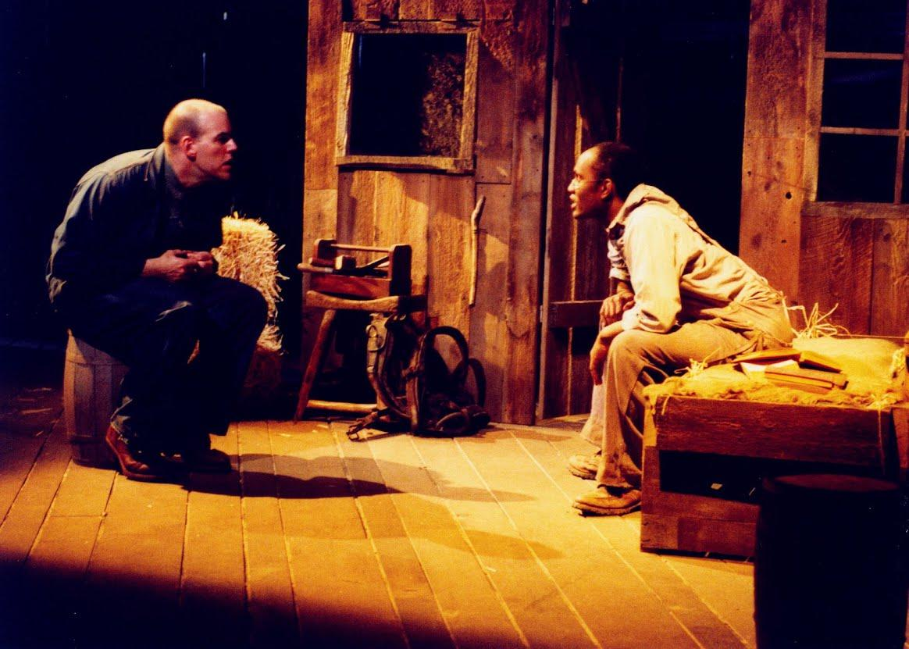

Crooks in Context: the Harlem Renaissance
Crooks is characterized by his bitterness and feeling of powerlessness. However, when Steinbeck was writing, a hugely significant cultural movement had already swept through the US: The Harlem Renaissance. The resources in this section will help you explore this Golden Age of African American culture, and can give you a sense of context for Crooks. It is interesting to see how this cultural awakening contrasts Crooks’ mindset, even though it is also motivated by a deep sense of injustice about racial discrimination. However, instead of bitterness, the hallmark of this movement was empowerment, lively debate and artistic creation.
Explore further!
The National Museum of African American History and Culture provides this overview: https://nmaahc.si.edu/explore/stories/new-african-american-identity-harlem-renaissance
- Their ‘Making a Way out of no Way’ online exhibition introduces you to broader themes in African American History: https://www.searchablemuseum.com/making-a-way-out-of-no-way
- There’s also an introduction to the Harlem Renaissance from a queer perspective: https://nmaahc.si.edu/explore/stories/harlem-renaissance-black-queer-history
- Or you can explore important artists of the time (https://nmaahc.si.edu/explore/stories/african-americans-jazz-and-poetry )
The Poetry Foundation offers this introduction with a focus on literature: : https://www.poetryfoundation.org/collections/145704/an-introduction-to-the-harlem-renaissance
The National Gallery of Art has online artworks to explore: https://www.nga.gov/learn/teachers/lessons-activities/uncovering-america/harlem-renaissance.html

The Harlem Renaissance in Poems and Extracts

The Measure, by Georgia Douglas Johnson

Fierce is the conflict—the battle of eyes,
Sure and unerring, the wordless replies,
Challenges flash from their ambushing caves—
Men, by their glances, are masters or slaves.
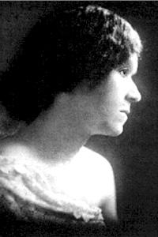

Freedom, By Langston Hughes
Freedom will not come
Today, this year
Nor ever
Through compromise and fear.

I have as much right
As the other fellow has
To stand
On my two feet
And own the land.

I tire so of hearing people say,
Let things take their course.
Tomorrow is another day.
I do not need my freedom when I’m dead.
I cannot live on tomorrow’s bread.
Freedom
Is a strong seed
Planted
In a great need.
I live here, too.
I want my freedom
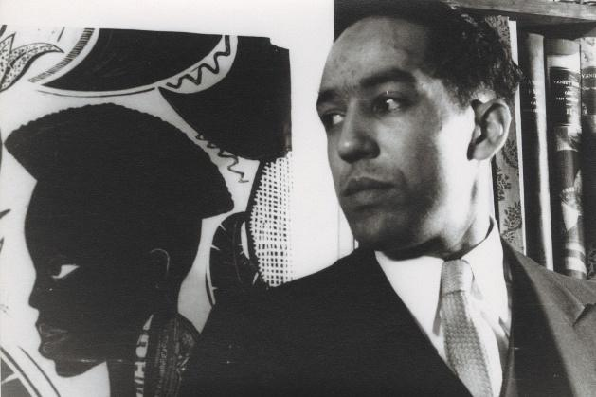
Just as you.

America, by Claude McKay
Although she feeds me bread of bitterness,
And sinks into my throat her tiger’s tooth,
Stealing my breath of life, I will confess
I love this cultured hell that tests my youth.
Her vigor flows like tides into my blood,
Giving me strength erect against her hate,
Her bigness sweeps my being like a flood.
Yet, as a rebel fronts a king in state,
I stand within her walls with not a shred
Of terror, malice, not a word of jeer.
Darkly I gaze into the days ahead,
And see her might and granite wonders there,
Beneath the touch of Time’s unerring hand,
Like priceless treasures sinking in the sand.



How it Feels to be Coloured Me, by Zora Neale Hurston:
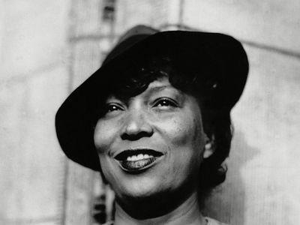
I AM COLORED but I offer nothing in the way of extenuating circumstances […]
I remember the very day that I became colored. Up to my thirteenth year I lived in the little Negro town of Eatonville, Florida. It is exclusively a colored town. The only white people I knew passed through the town going to or coming from Orlando. The native whites rodedusty horses, the Northern tourists chugged down the sandy village road in automobiles.
The town knew the Southerners and never stopped cane chewing when they passed. But the Northerners were something else again. They were peered at cautiously from behind curtains by the timid. The more venturesome would come out on the porch to watch them go past and got just as much pleasure out of the tourists as the tourists got out of the village.
The front porch might seem a daring place for the rest of the town, but it was a gallery seat for me. My favorite place was atop the gatepost. Proscenium box for a born firstnighter. Not only did I enjoy the show, but I didn't mind the actors knowing that I liked it. I usually spoke to them in passing. I'd wave at them and when they returned my salute, I would say something like this: "Howdy do? well? I thank you! Where you goin'?" Usually automobile or the horse paused at this, and after a queer exchange of compliments, I would probably "go a piece of the way" with them, as we say in farthest Florida. If one of my family happened to come to the front in time to see me, of course negotiations would be rudely broken off. But even so, it is clear that I was the first "welcome to our state" Floridian, and I hope the Miami Chamber of Commerce will please take notice.
During this period, white people differed from colored to me only in that they rode through town and never lived there. They liked to hear me I “speak pieces" and sing and wanted to see me dance, and gave me generously of their small silver for doing these things, which seemed strange to me for I wanted to do them so much that I needed bribing to stop, only they didn't know it. The colored people gave no dimes. They deplored any joyful tendencies in me, but I was their Zora nevertheless. I belonged to them, to the nearby hotels, to the county - everybody's Zora.
But changes came in the family when I was thirteen, and I was sent to school in Jacksonville. I left Eatonville, the town of the oleanders, a Zora. When I disembarked from the riverboat at Jacksonville, she was no more. It seemed that I had suffered a sea change. I was not Zora of Orange County any more, I was now a little colored girl. I found it out in certain ways. In my heart as well as in the mirror, I became a fast brown warranted not to rub nor run.
BUT I AM NOT tragically colored. There is no great sorrow dammed up in my soul, nor lurking behind my eyes. I do not mind at all. I do not be long to the sobbing school of Negrohood who hold that nature somehow has given them a lowdown dirty deal and whose feelings are all but about it. Even in the helterskelter skirmish that is my life, I have seen that the world is to the strong regardless of a little pigmentation more of less. No, I do not weep at the world?? I am too busy sharpening my oyster knife.
Someone is always at my elbow reminding me that I am the grand daughter of slaves. It fails to register depression with me. Slavery is sixty years in the past. The operation was successful and the patient is doing well, thank you. The terrible struggle that made me an American out of a potential slave said "On the line! " The Reconstruction said "Get set! " and the generation before said "Go! " I am off to a flying start and I must not halt in the stretch to look behind and weep. Slavery is the price I paid for civilization, and the choice was not with me. It is a bully adventure and worth all that 1 have paid through my ancestors for it. No one on earth ever had a greater chance for glory. The world to be won and nothing to be lost. It is thrilling to think to know that for any act of mine, I shall get twice as much praise or twice as much blame. It is quite exciting to hold the center of the national stage, with the spectators not knowing whether to laugh or to weep.
[…]
AT CERTAIN TIMES I have no race, I am me. When I set my hat at a certain angle and saunter down Seventh Avenue, Harlem City, feeling as snooty as the lions in front of the Forty Second Street Library, for instance. So far as my feelings are concerned, Peggy Hopkins Joyce on the Boule Mich with her gorgeous raiment, stately carriage, knees knocking together in a most aristocratic manner, has nothing on me. The cosmic Zora emerges. I belong to no race nor time. I am the eternal feminine with its string of beads. I have no separate feeling about being an American citizen and colored. I am merely a fragment of the Great Soul that surges within the boundaries. My country, right or wrong. Sometimes, I feel discriminated against, but it does not make me angry. It merely astonishes me. How can any deny themselves the pleasure of my company? It's beyond me.
But in the main, I feel like a brown bag of miscellany propped against a wall. Against a wall In company with other bags, white, red and yellow. Pour out the contents, and there is discovered a jumble of small, things priceless and worthless. A firstwater diamond, an empty spool bits of broken glass, lengths of string, a key to a door long since crumbled away, a rusty knifeblade, old shoes saved for a road that never was and never will be, a nail bent under the weight of things too heavy for any nail, a dried flower or two still a little fragrant. In your hand is the brown bag. On the ground before you is the jumble it held so much like the jumble in the bags could they be emptied that all might be dumped in a single heap and the bags refilled without altering the content of any greatly. A bit of colored glass more or less would not matter. Perhaps that is how the Great Stuffer of Bags filled them in the first place? who knows?

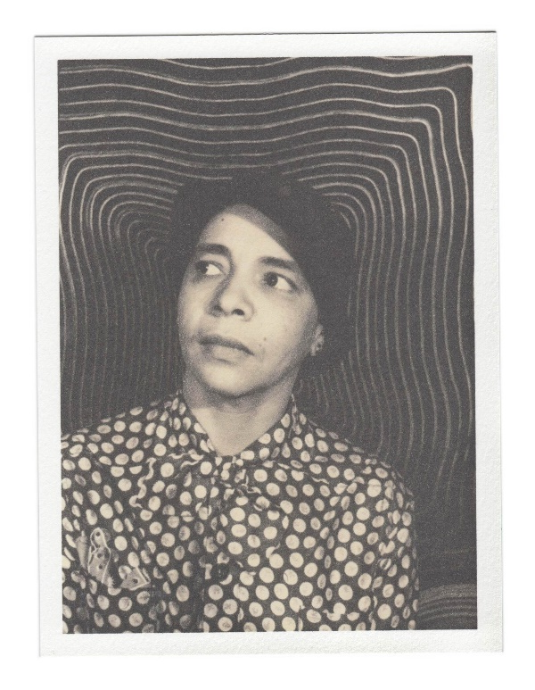
Passing, by Nella Larson

Irene Redfield is living an affluent, enviable life with her husband and children in the thriving African American enclave of Harlem in the 1920s. That is, until she runs into her childhood friend, Clare Kendry. Since they last saw each other, Clare, who is similarly light-skinned, has been “passing” for a white woman, married to a racist man who does not know about his wife’s real identity, which she has chosen to hide from the rest of the world.
It was the last letter in Irene Redfield's little pile of morning mail. After her other ordinary and clearly directed letters the long envelope of thin Italian paper with its almost illegible scrawl seemed out of place and alien. And there was, too, something mysterious and slightly furtive about it. A thin sly thing which bore no return address to betray the sender. Not that she hadn't immediately known who its sender was. Some two years ago she had one very like it in outward appearance. Furtive, but yet in some peculiar, determined way a little flaunting. Purple ink. Foreign paper of extraordinary size.
It had been, Irene noted, postmarked in New York the day before. Her brows came together in a tiny frown. The frown, however, was more from perplexity than from annoyance; though there was in her thoughts an element of both. She was wholly unable to comprehend such an attitude towards danger as she was sure the letter's contents would reveal; and she disliked the idea of opening and reading it.
This, she reflected, was of a piece with all that she knew of Clare Kendry. Stepping always on the edge of danger. Always aware, but not drawing back or turning aside. Certainly not because of any alarms or feeling of outrage on the part of others.
And for a swift moment Irene Redfield seemed to see a pale small girl sitting on a ragged blue sofa, sewing pieces of bright red cloth together, while her drunken father, a tall, powerfully built man, raged threateningly up and down the shabby room, bellowing curses and making spasmodic lunges at her which were not the less frightening because they were, for the most part, ineffectual. Sometimes he did manage to reach her. But only the fact that the child had edged herself and her poor sewing over to the farthermost corner of the sofa suggested that she was in any way perturbed by this menace to herself and her work.
Clare had known well enough that it was unsafe to take a portion of the dollar that was her weekly wage for the doing of many errands for the dressmaker who lived on the top floor of the building of which Bob Kendry was janitor. But that knowledge had not deterred her. She wanted to go to her Sunday school's picnic, and she had made up her mind to wear a new dress. So, in spite of certain unpleasantness and possible danger, she had taken the money to buy the material for that pathetic little red frock.
There had been, even in those days, nothing sacrificial in Clare Kendry's idea of life, no allegiance beyond her own immediate desire. She was selfish, and cold, and hard. And yet she had, too, a strange capacity of transforming warmth and passion, verging sometimes almost on theatrical heroics.
Irene, who was a year or more older than Clare, remembered the day that Bob Kendry had been brought home dead, killed in a silly saloon-fight. Clare, who was at that time a scant fifteen years old, had just stood there with her lips pressed together, her thin arms folded across her narrow chest, staring down at the familiar pasty-white face of her parent with a sort of disdain in her slanting black eyes. For a very long time she had stood like that, silent and staring. Then, quite suddenly, she had given way to a torrent of weeping, swaying her thin body, tearing at her bright hair, and stamping her small feet. The outburst had ceased as suddenly as it had begun. She glanced quickly about the bare room, taking everyone in, even the two policemen, in a sharp look of flashing scorn. And, in the next instant, she had turned and vanished through the door.
Seen across the long stretch of years, the thing had more the appearance of an outpouring of pent-up fury than of an overflow of grief for her dead father; though she had been, Irene admitted, fond enough of him in her own rather catlike way.
[…] The narrator is now in a nice café, and is feeling disturbed by a stranger….
Oh well, let her look! She tried to treat the woman and her watching with indifference, but she couldn't. All her efforts to ignore her, it, were futile. She stole another glance. Still looking. What strange languorous eyes she had!
And gradually there rose in Irene a small inner disturbance, odious and hatefully familiar. She laughed softly, but her eyes flashed. Did that woman, could that woman, somehow know that here before her very eyes on the roof of the Drayton sat a Negro? Absurd! Impossible!
White people were so stupid about such things for all that they usually asserted that they were able to tell; and by the most ridiculous means, finger-nails, palms of hands, shapes of ears, teeth, and other equally silly rot. They always took her for an Italian, a Spaniard, a Mexican, or a gipsy. Never, when she was alone, had they even remote; seemed to suspect that she was a Negro. No, the woman sitting there staring at her couldn't possibly know.
Nevertheless, Irene felt, in turn, anger, scorn, and fear slide over her. It wasn't that she was ashamed of being a Negro, or even of having it declared. It was the idea of being ejected from any place, even in the polite and tactful way in which the Drayton would probably do it, that disturbed her.
But she looked, boldly this time, back into the eyes still frankly intent upon her. They did not seem to her hostile or resentful. Rather, Irene had the feeling that they were ready to smile if she would. Nonsense, of course. The feel passed and she turned away with the firm intention to keep her gaze on the lake, the roofs of the buildings across the sky, anywhere but on that annoying woman. Almost immediately, however, her eyes were back again. Amidst her fog of uneasiness she had been seized by a desire to outstare the rude observer. Suppose the woman did know her race. She couldn't prove it.

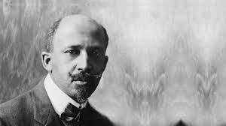
The Souls of Black Folk, W.E.B. DuBois
The Souls of Black Folk remains both a touchstone in literature and a beacon in the fight for civil rights. W. E. B. Du Bois charts a path forward against oppression, and introduces the now-famous concepts of the color line, the veil, and double-consciousness.

Between me and the other world there is ever an unasked question: unasked by some through feelings of delicacy; by others through the difficulty of rightly framing it. All, nevertheless, flutter round it. They approach me in a half-hesitant sort of way, eye me curiously or compassionately, and then, instead of saying directly, How does it feel to be a problem? they say, I know an excellent colored man in my town; or, I fought at Mechanicsville; or, Do not these Southern outrages make your blood boil? At these I smile, or am interested, or reduce the boiling to a simmer, as the occasion may require. To the real question, How does it feel to be a problem? I answer seldom a word.
And yet, being a problem is a strange experience,-peculiar even for one who has never been anything else, save perhaps in babyhood and in Europe. It is in the early days of rollicking boyhood that the revelation first bursts upon one, all in a day, as it were. I remember well when the shadow swept across me. I was a little thing, away up in the hills of New England, where the dark Housatonic winds between Hoosac and Taghkanic to the sea. In a wee wooden schoolhouse, something put it into the boys’ and girls’ heads to buy gorgeous visiting-cards-ten cents a package-and exchange. The exchange was merry, till one girl, a tall newcomer, refused my card,-refused it peremptorily, with a glance. Then it dawned upon me with a certain suddenness that I was different from the others; or like, mayhap, in heart and life and longing, but shut out from their world by a vast veil. I had thereafter no desire to tear down that veil, to creep through; I held all beyond it in common contempt, and lived above it in a region of blue sky and great wandering shadows. That sky was bluest when I could beat my mates at examination-time, or beat them at a foot-race, or even beat their stringy heads. Alas, with the years all this fine contempt began to fade; for the worlds I longed for, and all their dazzling opportunities, were theirs, not mine. But they should not keep these prizes, I said; some, all, I would wrest from them. Just how I would do it I could never decide: by reading law, by healing the sick, by telling the wonderful tales that swam in my head,-some way. With other black boys the strife was not so fiercely sunny: their youth shrunk into tasteless sycophancy, or into silent hatred of the pale world about them and mocking distrust of everything white; or wasted itself in a bitter cry, Why did God make me an outcast and a stranger in mine own house? The shades of the prison-house closed round about us all: walls strait and stubborn to the whitest, but relentlessly narrow, tall, and unscalable to sons of night who must plod darkly on in resignation, or beat unavailing palms against the stone, or steadily, half hopelessly, watch the streak of blue above.
After the Egyptian and Indian, the Greek and Roman, the Teuton and Mongolian, the Negro is a sort of seventh son, born with a veil, and gifted with second-sight in this American world,-a world which yields him no true self-consciousness, but only lets him see himself through the revelation of the other world. It is a peculiar sensation, this double-consciousness, this sense of always looking at one’s self through the eyes of others, of measuring one’s soul by the tape of a world that looks on in amused contempt and pity. One ever feels his twoness,-an American, a Negro; two souls, two thoughts, two unreconciled strivings; two warring ideals in one dark body, whose dogged strength alone keeps it from being torn asunder.

Women’s Literature: Read around Curley’s Wife!

Explore the character
In ‘Of Mice and Men’, women are treated with contempt – and don’t even have names! She appears on p. 32 and later in the novel.

- Consider how the character is introduced: on p. 32, what do we learn about her? What do we not learn about her? How would you describe the men’s reactions to her?

- When she leaves…. How would you describe the way in which the other characters talk about her when she has left?

- Explore how she is feeling: She is lonely – how is her sense of isolation presented?

- Think about characters’ relationships: As a character, she preys upon others’ weaknesses even when she herself feels vulnerable. Where in the novella can you detect this?

- Understanding the character by thinking about her dreams: She reveals to Lennie that she dreams of being a movie star (p. 87). How does this add to her character?

- Evaluate authorial intention: We noted earlier that Steinbeck’s novella explores the dangers of believing in dreams. What does Curley’s wife suggest about the predatory nature of human existence?

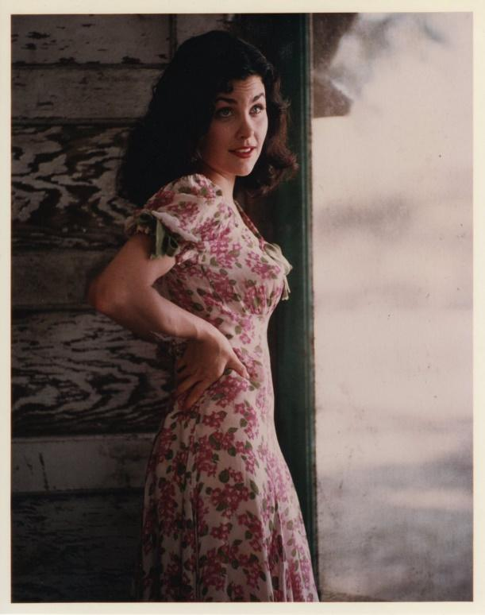

Curley’s Wife in Context: Women’s History
Curley’s wife is trapped, but actually, the world for women was changing rapidly at the time.
You can explore the history of feminism here:
- A great overview to click through is provided here https://www.womenshistory.org/exhibits/feminism-first-wave-0
- Learn about the ‘progressive Era’ (late 19th century up to the 1920s – not long before Of Mice and Men!) https://www.womenshistory.org/resources/video/womens-history-minute-progressive-era
- What was this like in the UK? Explore here https://www.bbc.co.uk/bitesize/clips/zmr4pg8
Inspirational historical women of ‘Curley’s Wife’s’ time:
- Watch a short video about Dorothea Lange, a photographer working around the time when ‘Of Mice and men’ is set: https://www.womenshistory.org/resources/video/womens-history-minute-dorothea-lange
- Meet Edith Clarke, the first women to be employed as an electrical engineer in the US: https://www.womenshistory.org/resources/video/womens-history-minute-edith-clarke
- Learn about a female pioneer in aviation here https://www.womenshistory.org/resources/video/womens-history-minute-flight
- Explore the world of the movies and Hollywood with actors Mary Pickford: https://www.womenshistory.org/resources/video/womens-history-minute-mary-pickford and Anna May Wong https://wams.nyhistory.org/confidence-and-crises/jazz-age/anna-may-wong/
How did everything continue? This page offers an overview of so-called ‘Second-Wave Feminism’ with lots of videos to help you explore the women’s movements of the 1970s https://www.bbc.co.uk/archive/second-wave-feminism/zdhw382
How about today?
You can explore representations of women in the media with BBC Bitesize: https://www.bbc.co.uk/bitesize/guides/zq6qsg8/revision/1

Women’s Literature in Poems and Extracts

Amelia Earhart’s Advice to a young aspiring adventurer
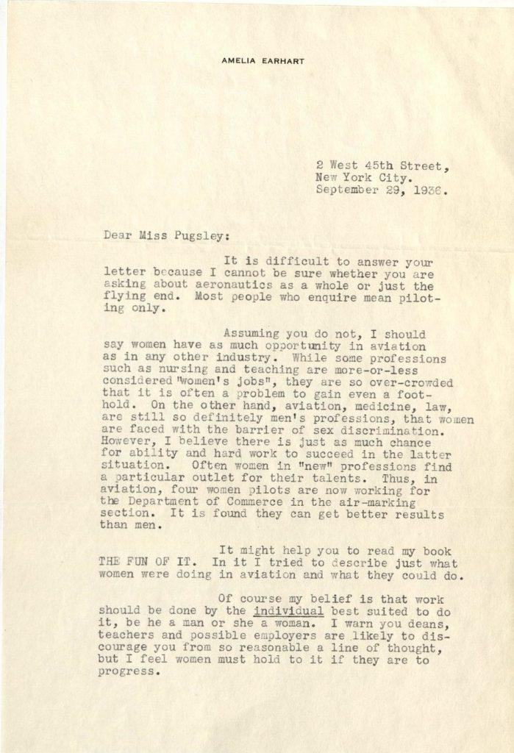
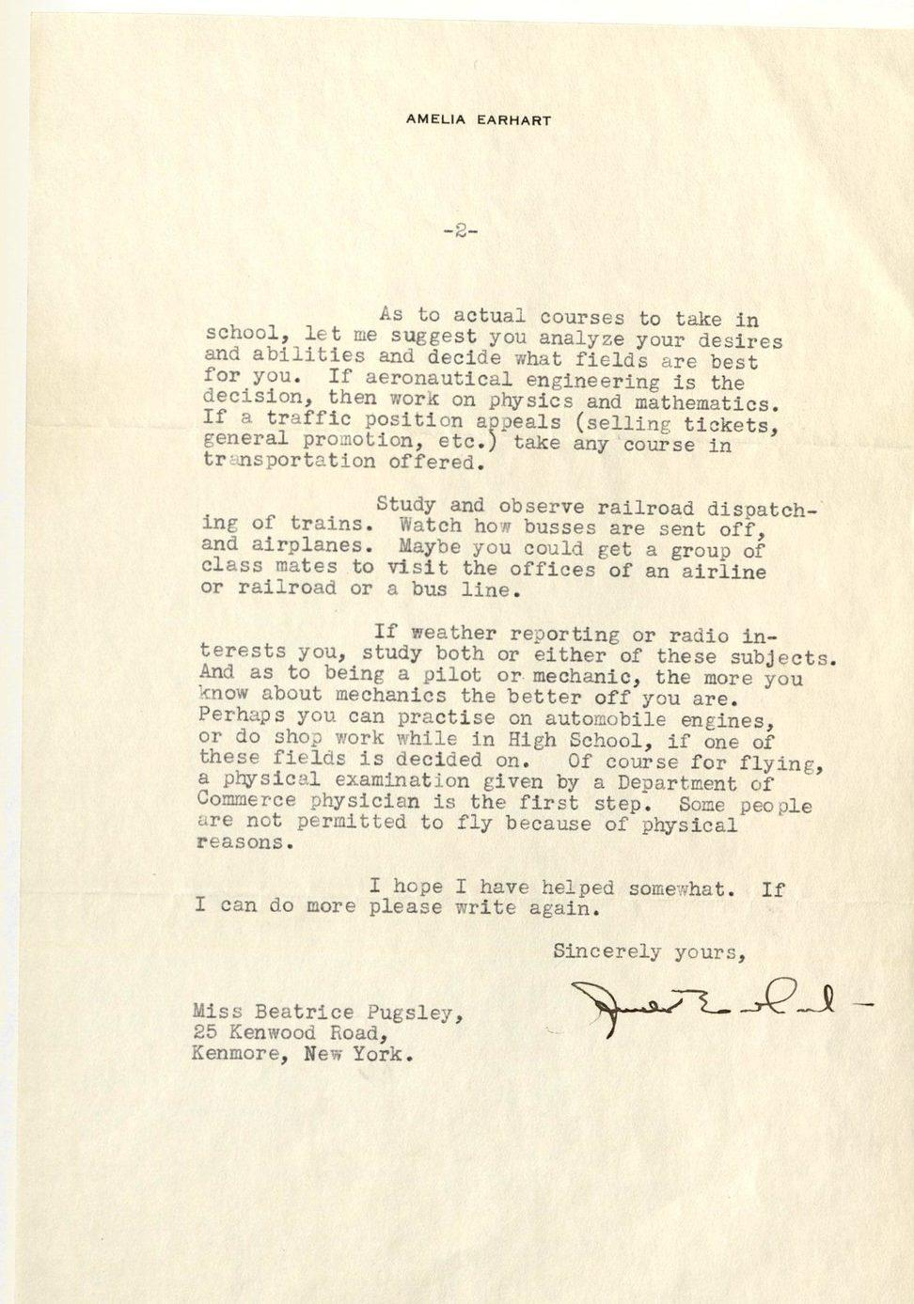

From ‘Save me the Waltz’ by Zelda Fitzgerald
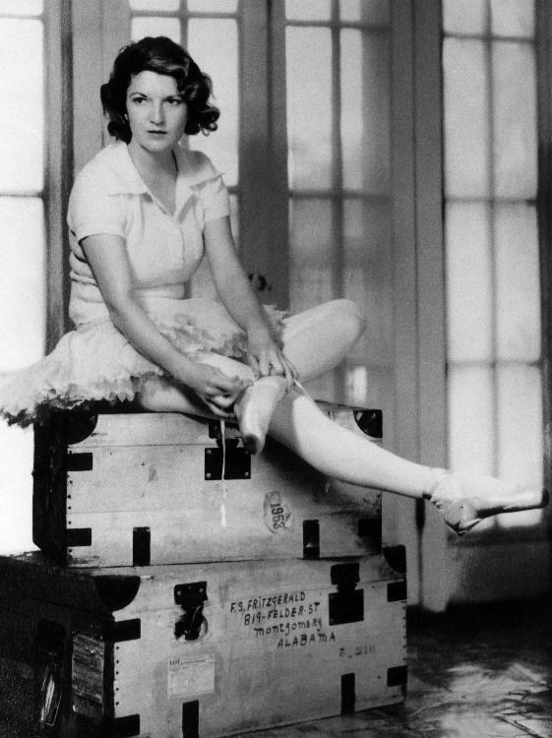
The girl had been filled with no interpretation of herself, having been born so late in the life of her parents that humanity had already disassociated itself from their intimate consciousness and childhood become more ot a concept than the child. She wants to be told what she is like, being too young to know that she is like nothing at all and will fill out her skeleton with what she gives off, as a general might reconstruct a battle following the advances and recessions of his forces with bright-colored pins. She does not know that what effort she makes will become herself. It was much laler that the child, Alabama, came to realize that the bones ol her father could indicate only her limitations.
“And did I cry at night and raise hell so you and Daddy wished I was dead?”
“What an idea! All my children were sweet children.”
“And Grandma’s, too?”
“I suppose so.”
“Then why did she run Uncle Cal away when he came home from the Civil War?”
“Your grandmother was a queer old lady.”
“Cal, too?”
“Yes. When Cal came home, Grandma sent word to Florence Feather that if she was waiting for her to die to marry Cal, she wanted the Feathers to know that the Beggs were a long-lived race.”
“Was she so rich?”
“No. lt wasn’t money. Florence said nobody but the devil could live with Cal’s mother.”
“So Cal didn’t marry, after all?”
“No—grandmothers always have their way.”
The mother laughs—the laugh of a profiteer recounting incidents of business prowess, apologetic of its grasping security, the laugh ot the family triumphant, worsting another triumphant family in the eternal business of superimposition.
“If I’d been Uncle Cal I wouldn’t have stood it,” the child proclaims rebelliously. “I’d have done what I wanted to do with Miss Feather.”
The deep balance of the father’s voice subjugates the darkness to the final diminuendo of the Beggs’ bedtime.
“Why do you want to rehash all that?” he says judiciously.
Closing the shutters, he boxes the special qualities of his house: an affinity with light, curtain frills penetrated by sunshine till the pleats wave like shaggy garden borders about the flowered chintz. Dusk leaves no shadows or distortions in his rooms but transfers them to vaguer, grayer worlds, intact. Winter and spring, the house is like some lovely shining place painted on a mirror. When the chairs fall to pieces and the carpels grow full of holes, it does not matter in the brightness of that presentation. The house is a vacuum for the culture of Austin Beggs’ integrity. Like a shining sword it sleeps at night in the sheath of his tired nobility.
The tin roof pops with the heat; the air inside is like a breath from a long unopened trunk. There is no light in the transom above the door at the head of the upstairs hall.
“Where is Dixie?” the father asks.
“She’s out with some friends.”
Sensing the mother’s evasiveness, the little girl draws watchfully close, with an important sense of participation in family affairs.
“Things happen lo us,” she thinks. “What an interesting thing to be a family.”
“Millie,” her father says, “if Dixie is out traipsing the town with Randolph Mclntosh again, she can leave my house for good.”
Her lather’s head shakes with anger, outraged decency loosens the eyeglasses from his nose. The mother walks quietly over ihe warm matting of her room, and the little girl lies in the dark, swelling virtuously submissive to the way of the clan. Her father goes down in his cambric nightshirt to wail.
From the orchard across the way the smell of ripe pears floats over the child’s bed. A band rehearses waltzes in the distance. White things gleam in the dark—white flowers and paving stones. The moon on the windowpanes careens to the garden and ripples the succulent exhalations of the earth like a silver paddle. The world is younger than it is, and she to herself appears so old and wise, grasping her problems and wrestling with them as affairs peculiar to herself and not as racial heritages. There is a brightness and bloom over things; she inspects life proudly, as if she walked in a garden forced by herself to grow in the least hospitable of soils. She is already contemptuous of ordered planting, believing in the possibility of a wizard cultivator to bring forth sweet-smelling blossoms from the hardest of rocks, and night-blooming vines from barren wastes, to plant the breath of twilight and to shop with marigolds. She wants life to be easy and full of pleasant reminiscences.
Thinking, she thinks romantically on her sister’s beau. Randolph’s hair is like nacre cornucopias pouring forth those globes of light that make his face. She thinks that she is like that inside, thinking in this nocturnal confusion of her emotions with her response to beauty. She thinks of Dixie with excited identity as being some adult pan of herself divorced from her by transfiguring years, like a very sunburned arm which might not appear familiar if you had been unconscious of its alterations. To herself, she appropriates her sister’s love affair. Her alertness makes her drowsy. She has achieved a suspension of herself with the strain of her attenuated dreams. She falls asleep. The moon cradles her tanned face benevolently. She grows older sleeping. Someday she will awake to observe the plants of Alpine gardens in be largely fungus things, needing little sustenance, and the white discs that perfume midnight hardly flowers at all but embryonic growths; and, older, walk in bitterness the geometrical paths of philosophical Le Notres rather than those nebulous byways of the pears and marigolds of her childhood.
Alabama never could place what woke her mornings as she lay staring about, conscious of the absence of expression smothering her face like a wet bath mat. She mobilized herself. Live eyes of a soft wild animal in a trap peered out in skeptic invitation from the taut net of her features; lemon-yellow hair melted down her back. She dressed herself for school with liberal gestures, bending forward to watch the movements of her body. The schoolbell on the still exudings of the South fell flat as the sound of a buoy on the vast mufflings of the sea. She tiptoed into Dixie’s room and plastered her face with her sister’s rouge.
When people said, “Alabama, you’ve got rouge on your face,” she simply said, “I’ve been scrubbing my face with the nailbrush.”

Edna St. Vincent Millay, Departure
It's little I care what path I take,
And where it leads it's little I care,
But out of this house, lest my heart break,
I must go, and off somewhere!
It's little I know what's in my heart,
What's in my mind it's little I know,
But there's that in me must up and start,
And it's little I care where my feet go!
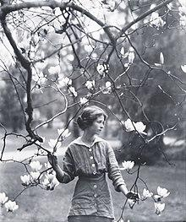
I wish I could walk for a day and a night,
And find me at dawn in a desolate place,
With never the rut of a road in sight,
Or the roof of a house, or the eyes of a face.
I wish I could walk till my blood should spout,
And drop me, never to stir again,
On a shore that is wide, for the tide is out,
And the weedy rocks are bare to the rain.
But dump or dock, where the path I take
Brings up, it's little enough I care,
And it's little I'd mind the fuss they'll make,
Huddled dead in a ditch somewhere.
"Is something the matter, dear," she said,
"That you sit at your work so silently?"
"No, mother, no—'twas a knot in my thread.
There goes the kettle—I'll make the tea."

From ‘The Yellow Wallpaper’ by Charlotte Perkins Gilman
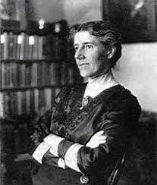
The narrator and her husband, John, have rented a large house for the summer. The extract begins with the narrator describing the room she has been given to sleep in at the top of the house.

The wallpaper is dull enough to confuse the eye in following, but pronounced enough to constantly irritate and provoke study, and when you follow the lame uncertain curves for a little distance they suddenly commit suicide—plunge off at outrageous angles. The colour is repellent, almost revolting: a smouldering unclean yellow, strangely faded by the slow-turning sunlight. It is a dull yet lurid orange in some places, a sickly sulphur tint in others.
There comes John, and I must put this away; he must not see me writing again.
I told him about my idea to redecorate. "You know the place is doing you good," he said, "and really, dear, I don't care to renovate the house just for a three months' rental."
"Then do let me move downstairs," I said, "there are such pretty rooms there." Then he took me in his arms and called me a blessed little goose, and said he would go down to the cellar, if I wished, and have it whitewashed into the bargain.
But he is right enough. I'm really getting quite fond of the big room, all but that horrid paper.
In the pattern there is a recurrent spot where the pattern lolls like a broken neck and two bulbous eyes stare at you upside down. Up and down and sideways they crawl, and those absurd, unblinking eyes are everywhere. There is one place where two breadths didn't match, and the eyes go all up and down the line, one a little higher than the other. I never saw so much expression in an inanimate thing before, and we all know how much expression they have! I used to lie awake as a child and get more entertainment and terror out of blank walls and plain furniture than most children could find in a toy store.
The colour is hideous enough, and unreliable enough, and infuriating enough, but the pattern is torturing.
You think you have mastered it, but just as you get well underway in following, it turns a back-somersault and there you are. It slaps you in the face, knocks you down, and tramples upon you. It is like a bad dream.
The outside pattern is a florid arabesque, reminding one of a fungus. If you can imagine a toadstool in joints, an interminable string of toadstools, budding and sprouting in endless convolutions—why, that is something like it.
I'm feeling ever so much better! I don't sleep much at night, for it is so interesting to watch developments, but I sleep a good deal in the daytime. There are always new shoots on the fungus, and new shades of yellow all over it. I cannot keep count of them, though I have tried conscientiously.
It is the strangest yellow, that wall-paper! It makes me think of all the yellow things I ever saw—not beautiful ones like buttercups, but old foul, bad yellow things. There is something else about that paper—the smell! I noticed it the moment we came into the room, but with so much air and sun it was not bad. Now we have had a week of fog and rain, and whether the windows are open or not, the smell is here.
It creeps all over the house.
The smell used to disturb me at first. I thought seriously of burning the house—to reach the smell. But now I am used to it. The only thing I can think of that it is like is the colour of the paper: a yellow smell.
I really have discovered something at last. Through watching so much at night, when it changes so, I have finally found out. The front pattern does move - and no wonder! The woman behind shakes it! Sometimes I think there are a great many women behind, and sometime only one, and she crawls around fast, and her crawling shakes it all over. Then in the very bright spots she keeps still, and in the very shady spots she just takes hold of the bars and shakes them hard. And she is all the time trying to climb through. But nobody could climb through that pattern - it strangles so; I think that is why it has so many heads. They get through, and then the pattern strangles them off and turns them upside down, and makes their eyes white! If those heads were covered or taken off it would not be half so bad.
I think that woman gets out in the daytime! And I'll tell you why - privately ¬ I've seen her! I can see her out of every one of my windows! It is the same woman, I know, for she’s always creeping, and most women do not creep by daylight. I see her in that long shaded lane, creeping up and down. I see her in hose dark grape arbours, creeping all around the garden. I see her on that long road under the trees, creeping along, and when a carriage comes she hides under the blackberry vines. I don't blame her a bit. It must be very humiliating to be caught creeping by daylight! I always lock the door when I creep by daylight. I can't do it at night, for I know John would suspect something at once.

