

Is Memory ‘Multidirectional’ in Beloved?

Critical Perspective: Michael Rothberg’s ‘Multidirectional Memory’, 2009
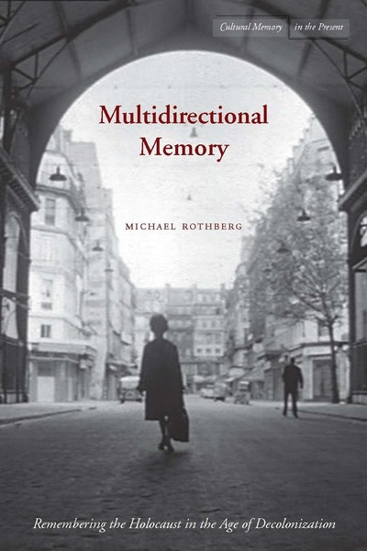
Michael Rothberg is Professor of English and Comparative Literature at the University of California, Los Angeles.
In his 2009 book Multidirectional Memory, he explores how the Holocaust is remembered, and focuses very much on the cultural side of memory, not just on individuals. He starts with the observation that there is often a misunderstanding about how we remember as a society: he describes how public discourse in the media often seems to assume that different memories clash and vie for attention – for example, remembering slavery might mean that memories of the Holocaust or of the genocide of the indigenous population in today’s US get pushed aside. He argues that this idea of a ‘zero-sum game’ of memory is wrong. Instead, he proposes that memories of these different past events are connected and help bring each other to the surface. For example, he explores how civil rights movement (which focused on decolonialisation and slaver) helped articulate memories of the Holocaust, and vice versa. In the end, Rothberg sees memory as a dialogue – remembering one event can help uncover and articulate another.
Explore this idea:
- Read more about the idea of ‘Multidirectional Memory’ in this interview with Michael Rothberg here: https://europeanmemories.net/magazine/multidirectional-memory-in-focus/
Create a mind-map of the different ideas in relation to memory he discusses in this interview. Highlight those that you expect to be most important for Beloved
- Go to the website of the National Museum of African American History and Culture, and explore the ‘Slavery and Freedom’ exhibition here https://www.searchablemuseum.com/slavery-and-freedom
Beyond today’s US, which other countries are part of the memory that is being constructed here?
Which cultures and people beyond enslaved African Americans are integrated in the exhibition?
Evaluate: In this particular exhibition, is slavery presented mainly as a memory in its own right, or as a connected, ‘multidirectional’ memory which brings memories of other past events to the foreground, too?
Multidirectional Memory in Beloved – Sixo and Paul D:
Read about Paul D’s escape on p. 130-133, and about Sixo on p. 25-30.
How does Toni Morrison incorporate references to indigenous genocide in her novel? Discuss and evaluate!

