Please join us for the bi-monthly The Eccles Centre Digital Salon, an online forum that showcases research outputs undertaken by Eccles Fellows and Award winners at the British Library.

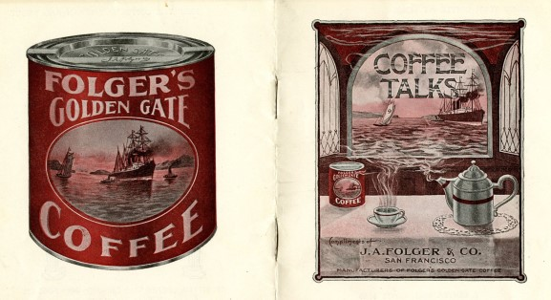

The Digital Salon on Tuesday 5 September (16.30-17.30 UK time) will spotlight the work of Dr Catherine V. Bateson, associate lecturer in American history at the University of Kent, examining the culture and sentiments of Irish American Civil War Songs.

The author will speak about her book Irish-American Civil War Songs: Identity, Loyalty and Nationhood (LSU Press, 2022), developed with the support of her Eccles Visiting Fellowship in 2015. Her talk will be followed by an informal audience discussion, facilitated by the Eccles Centre team.

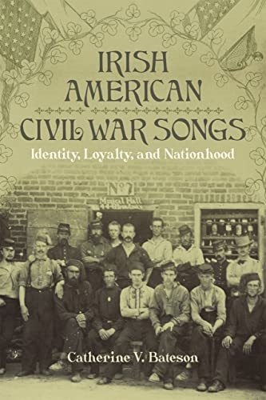

Catherine V. Bateson’s Irish American Civil War Songs provides the first in-depth exploration of Irish Americans’ use of balladry and song lyrics to share their wartime experiences and crucial engagement in the American Civil War. The author explores the feelings and opinions of Irish diasporic communities about the war through the analysis of a vast trove of ballads in songbooks, letters, newspaper publications, wartime diaries, and other accounts.
Bateson’s investigation of Irish American song lyrics is part of a wider research to understand the Irish emigrant experience in the 19th century United States, and provides a broader context of the diaspora contribution to the American Civil War. Her research also demonstrates how Irish songs shaped many American balladry traditions as they laid the foundation of the Civil War’s musical soundscape.
The Digital Salon is an opportunity for British Library colleagues, external researchers, and anyone interested to explore the ideas raised by the talk or to discuss the British Library’s Americas collections.

Dr Catherine V Bateson is an Associate Lecturer in American History at the University of Kent in the UK, where she teaches a wide variety of eighteenth and nineteenth century subjects, including aspects of American slavery, African American studies and Civil War history. She received her Eccles Visiting Fellowship in 2015, and then earned her PhD in History in 2018 at the University of Edinburgh. She is also an Associate Editor of the Irish in the American Civil War project and the former Vice-Chair of the Scottish Association for the Study of America.

For more information about the publication, please check the link: LSU Press :: Books - Irish American Civil War Songs

Please register for the event here:
https://us02web.zoom.us/meeting/register/tZMoc--hpz0jEtBL5mJKjfr6jyfP19bcDIAe

For more information about the Eccles Centre’s Coffee Breaks, please check the link: Eccles Centre Monthly Coffee Breaks| Events – The British Library | The British Library (bl.uk)

If you have any questions, please email the Eccles Centre at eccles-centre@bl.uk

