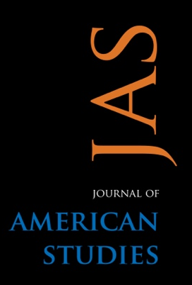
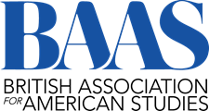

Call for Participants
Early Career Academic Article Development Workshop
The British Association of American Studies (BAAS) and the Journal of American Studies (JAS) are delighted to announce our first annual Early Career Academic Article Development Workshop. This workshop is designed to address disparities in representation in the sphere of academic publishing. To that end, we are specifically soliciting papers from doctoral candidates and early career scholars who belong to communities that are historically underrepresented in the profession.
This two-day workshop offers ECAs who have yet to publish in a peer-reviewed venue the opportunity to develop an academic journal article from draft to near-finished product. Participants will submit a draft to be circulated with two editors drawn from the JAS editorial board and BAAS community. These will provide detailed editorial suggestions in the style of Review 1 and Review 2. Alongside this individualised feedback, there will be information sessions on topics such as: the publishing process, common challenges, and peer-to-peer feedback and networking sessions. Each participant will also meet one-on-one with one of the JAS Co-Editors in Chief, who will mediate the feedback and provide guidance on next steps.
We are seeking several participants to take part in this two-day workshop. The workshop will take place in London, UK as an in-person event. Financial support will be provided for participants to enable travel. The aim is that the workshop and peer-mentorship will ultimately lead to the submission of the article in the Journal of American Studies.
This workshop welcomes applicants from a diverse range of disciplines that pertain to American Studies, but please note that it is specifically intended to support scholars who are working on their first published article, and those who are from underrepresented backgrounds in the academy, including women, BIPOC, and LGBTQ academics.
Workshop timescale (subject to change contingent on strike action)
- Application deadline is the 1st of March 2023
- Successful applicants will be informed by 22nd of March 2023
- Articles must be drafted and submitted by 15th of May
- The workshop will take place in June or September 2023 depending on the availability of the editors and the shape that the UCU strike action takes.

To apply for this workshop:
Please attach a brief CV and Cover Letter explaining your suitability for this opportunity. We would also require an article title and an article abstract.
Closing date for applications is midnight on the evening of the 1st of March 2023.
Please send application materials, and any further questions, to the workshop organisers: Christine Okoth (Christine.okoth@baas.ac.uk), Emily Brady (emily.brady@baas.ac.uk) and Rachele Dini (Rachele.dini@baas.ac.uk).

